# ML_Python

## Supervised Learning with scikit-learn

#### Basics

* What is it?



* Types:

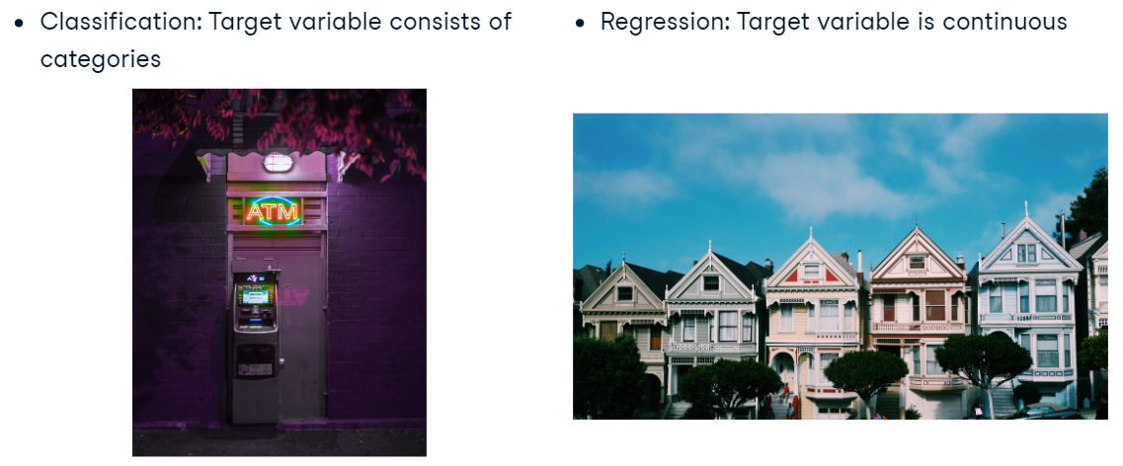

* Binary classification is used to predict a target variable that has only two labels, typically represented numerically with a zero or a one.
* Variables:

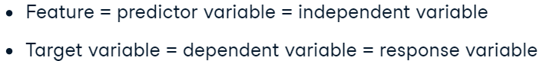

**Requirements**

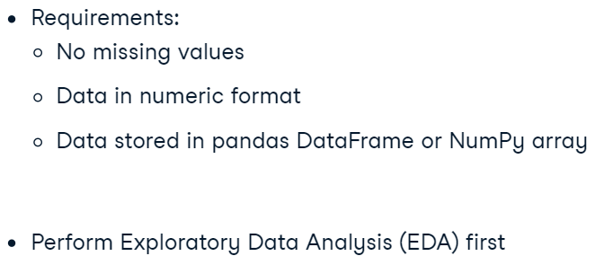

* Syntax:

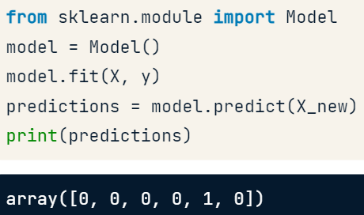

* Classifying **labels** of unseen data (**Labeled data == training data**):

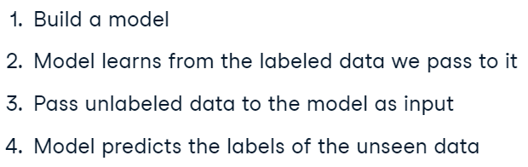

* Overfitting and underfitting:

1. **Переобучение (overfitting)**: Переобучение происходит, когда модель слишком точно подстраивается под обучающие данные и теряет способность обобщать на новые данные. Это приводит к тому, что модель хорошо работает на обучающем наборе данных, но плохо справляется с новыми данными. При переобучении модель "запоминает" шум и ненужные детали обучающих данных, что снижает ее способность к обобщению.
2. **Недообучение (underfitting)**: Недообучение происходит, когда модель слишком проста или не учитывает достаточно информации из обучающих данных, что приводит к плохим результатам как на обучающем, так и на тестовом наборе данных. Модель не может выявить закономерности в данных из-за своей простоты или неадекватности выбранной структуры модели.

### K-Nearest Neighbors

* What is it?

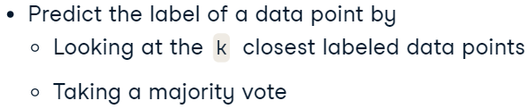

* + Example:

If k equals three, we would classify it as red. **This is because two of the three closest observations are red**.

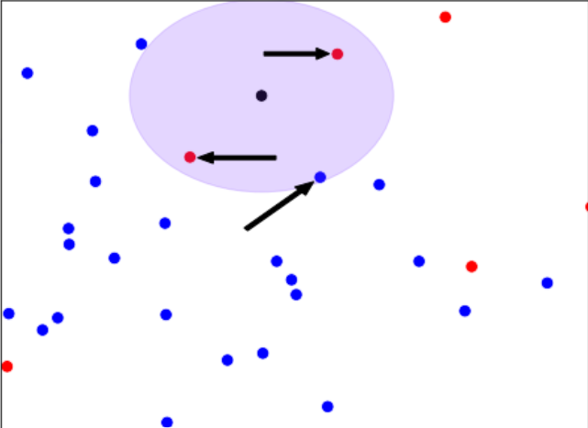

* Code:

from sklearn.neighbors import KNeighborsClassifier

X = churn_df[["account_length", "customer_service_calls"]].values

y = churn_df['churn'].values

knn = KNeighborsClassifier(n_neighbors=6)

knn.fit(X, y)

* Prediction:

y_pred = knn.predict(X_new)

print("Predictions: {}".format(y_pred))

result:

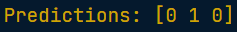

#### Measuring model performance

* Compute accuracy:

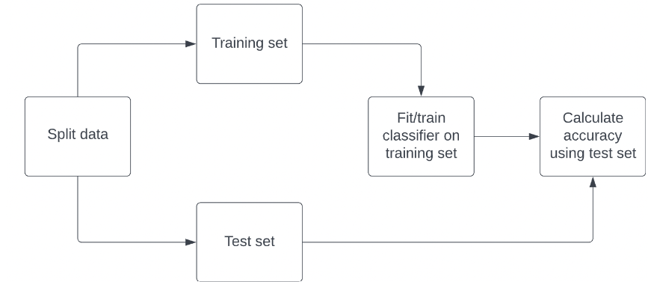

* Model complexity:

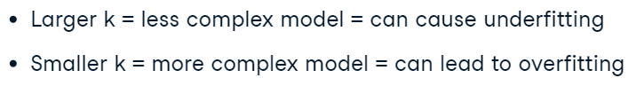

* Code for model:

from sklearn.model_selection import train_test_split

X = churn_df.drop("churn", axis=1).values

y = churn_df["churn"].values

X_train, X_test, y_train, y_test = train_test_split(X, y,

                                                    test_size=0.2,

                                                    random_state=42,

                                                    stratify=y)

knn = KNeighborsClassifier(n_neighbors=5)

knn.fit(X_train, y_train)

print(knn.score(X_test, y_test))

* + **test_size** – этот параметр говорит функции train_test_split, какую часть данных вы хотите оставить для тестирования (например, 20% или 0.2). Оставшаяся часть будет использоваться для обучения модели;
  + **random_state** – этот параметр гарантирует, что при каждом запуске программы данные будут разбиваться одинаковым образом. Это важно для воспроизводимости результатов вашей модели;
  + **stratify** – если у вас есть целевая переменная (например, классы в задаче классификации), и вы установите stratify=True, то данные будут разбиты таким образом, чтобы сохранить пропорции классов как в обучающей, так и в тестовой выборках. Это помогает избежать смещения в данных и делает разбиение более справедливым.

result:

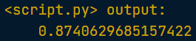

* + Accuracy assessing:

neighbors = np.arange(1, 13)

train_accuracies = {}

test_accuracies = {}

for neighbor in neighbors:

    knn = KNeighborsClassifier(n_neighbors=neighbor)

    knn.fit(X_train, y_train)

    train_accuracies[neighbor] = knn.score(X_train, y_train)

    test_accuracies[neighbor] = knn.score(X_test, y_test)

print(neighbors, '\n', train_accuracies, '\n', test_accuracies)

result:



* Vizualizing tour model perfomance:

plt.title('KNN: Varying Number of Neighbors')

plt.plot(neighbors,

        train_accuracies.values(),

        label='Training Accuracy'

        )

plt.plot(neighbors,

        test_accuracies.values(),

        label='Testing Accuracy'

        )

plt.legend()

plt.xlabel("Number of Neighbors")

plt.ylabel("Accuracy")

plt.show()

result:

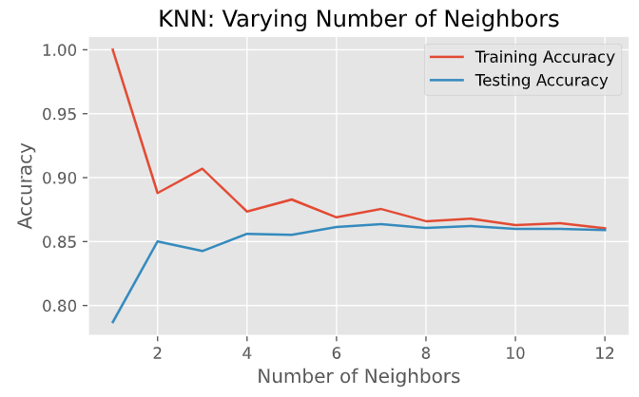

* Explonation:

Training accuracy decreases and test accuracy increases as the number of neighbors gets larger. For the test set, accuracy peaks with 7 neighbors, suggesting it is the optimal value for our model.

### Regression

* How it works:

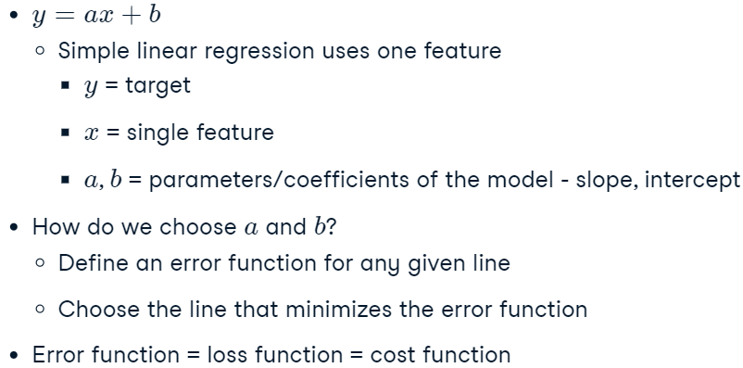

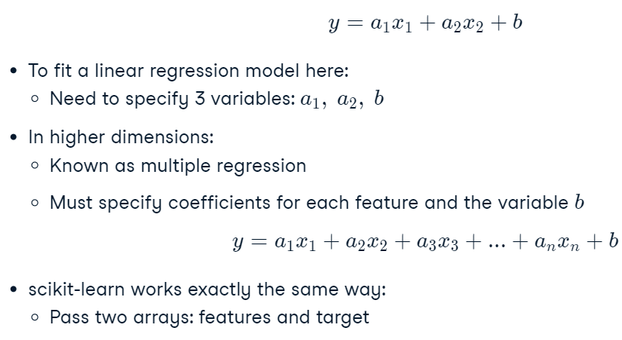

* **Reshape** DF for modeling:

X = sales_df['radio']

y = sales_df['sales']

X = X.values.reshape(-1, 1)

print(X.shape, y.shape)

result:

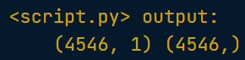

* Creating model:

from sklearn.linear_model import LinearRegression

reg = LinearRegression()

reg.fit(X, y)

predictions = reg.predict(X)

print(predictions[:5])

result:



* Viz predictions:

import matplotlib.pyplot as plt

plt.scatter(X, y, color='blue')

plt.plot(X, predictions, color='red')

plt.xlabel("Radio Expenditure ($)")

plt.ylabel("Sales ($)")

plt.show()

result:

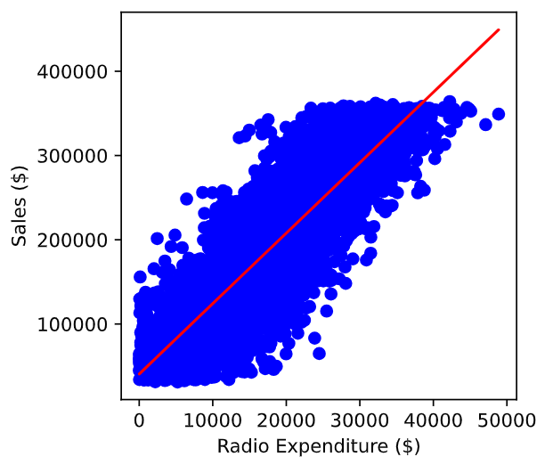

#### Metrics

* Ordinate least squares:

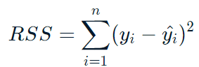

* R-squared:



* MSE / RMSE:

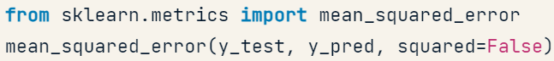

* + Code:

from sklearn.metrics import mean_squared_error

r_squared = reg.score(X_test, y_test)

rmse = mean_squared_error(y_test, y_pred, squared=False)

print("R^2: {}".format(r_squared))

print("RMSE: {}".format(rmse))

result:

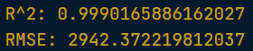

#### Creating model

* Code:

from sklearn.linear_model import LinearRegression

from sklearn.model_selection import train_test_split

X = sales_df.drop('sales', axis=1).values

y = sales_df['sales'].values

X_train, X_test, y_train, y_test = train_test_split(X, y,

                                                    test_size=0.3,

                                                    random_state=42)

reg = LinearRegression()

reg.fit(X_train, y_train)

y_pred = reg.predict(X_test)

print("Predictions: {}, Actual Values: {}".format(y_pred[:2], y_test[:2]))

result:



#### Cross-validation

*Cross-validation is a vital approach to evaluating a model. It maximizes the amount of data that is available to the model, as the model is not only trained but also tested on all of the available data.*

1. Улучшает обобщающую способность модели: позволяет оценить, насколько модель будет работать на новых данных, и предотвращает переобучение.
2. Эффективно использует данные: каждый пример данных используется как для обучения, так и для проверки модели.
3. Позволяет более точно оценить производительность модели: результаты усредняются по нескольким прогонам, что уменьшает влияние случайных факторов на оценку.

* What is it:

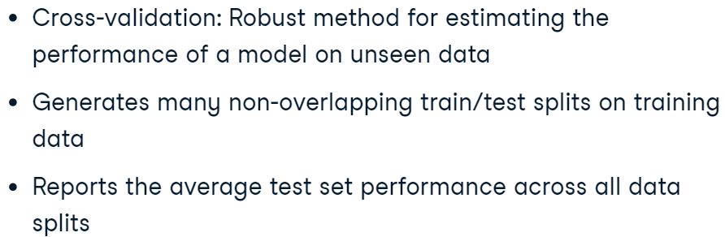

* Why do we use it?

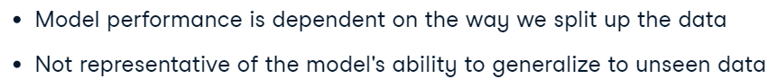R-squared

* How to calculate it:

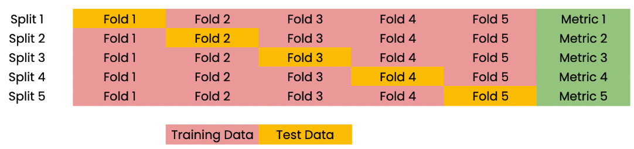

##### Model

* Code:

from sklearn.linear_model import LinearRegression

from sklearn.model_selection import cross_val_score, KFold

kf = KFold(shuffle=True, n_splits=6, random_state=5)

reg = LinearRegression()

cv_scores = cross_val_score(reg, X, y, cv=kf)

print(cv_scores)

* + Shuffle – перемешивает данные перед работой модели.

result:



* Assesing it:

print(np.mean(cv_results))

print(np.std(cv_results))

print(np.quantile(cv_results, [0.025, 0.975]))

result:

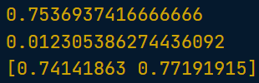

#### Regularized regression

* What is it?

*Регуляризация в машинном обучении — это метод,* ***используемый для уменьшения переобучения*** *модели путем добавления дополнительных ограничений или штрафов к функции потерь. Основная цель регуляризации состоит в том, чтобы предотвратить модель от слишком сильного подстраивания к обучающим данным и обеспечить лучшую обобщающую способность на новых данных.*

* Why we use it:

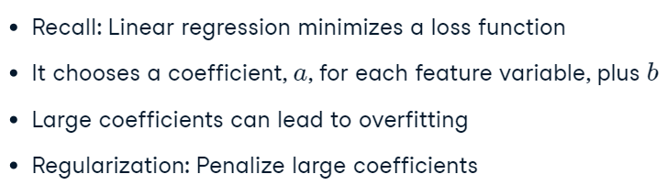

##### Ridge regression

Модель штрафуется за большие значения весов, добавляя к функции ошибки сумму абсолютных значений весов. Это может привести к тому, что некоторые веса станут нулевыми, что позволяет сделать отбор наиболее важных признаков и уменьшить размерность данных.

В гребневой регрессии коэффициенты и параметр регуляризации работают вместе, чтобы найти **баланс между точностью предсказаний и обобщающей способностью модели обучаться на новых данных**.

* What is it?

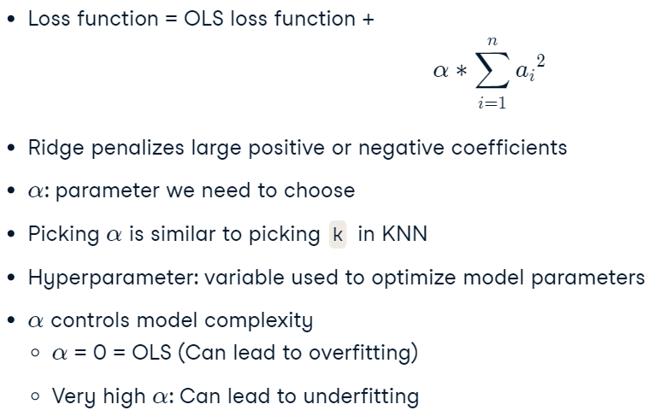

* Code:

from sklearn.linear_model import Ridge

alphas = [0.1, 1.0, 10.0, 100.0, 1000.0, 10000.0]

ridge_scores = []

for i in alphas:

  ridge = Ridge(alpha=i)

  ridge.fit(X_train, y_train)

  score=ridge.score(X_test, y_test)

  ridge_scores.append(score)

print(ridge_scores)

result:



* + Explonation:

The scores don't appear to change much as alpha increases, which is indicative of how well the features explain the variance in the target – even by heavily penalizing large coefficients, underfitting does not occur!

##### Lasso regression

* What is it?

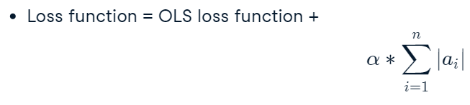

* Why do we use it:

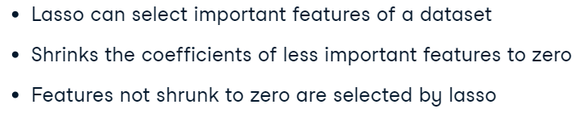

* Code:

from sklearn.linear_model import Lasso

alphas = [0.1, 1.0, 10.0, 100.0, 1000000000]

ridge_scores = []

for i in alphas:

  ridge = Lasso(alpha=i)

  ridge.fit(X_train, y_train)

  score=ridge.score(X_test, y_test)

  ridge_scores.append(score)

print(ridge_scores)

result:



* **Feature selection** – lasso regression can be used to identify important features in a dataset:

from sklearn.linear_model import Lasso

lasso = Lasso(alpha=0.3)

model = lasso.fit(X, y)

lasso_coef = model.coef_

print(lasso_coef)

plt.bar(sales_columns, lasso_coef)

plt.xticks(rotation=45)

plt.show()

result:



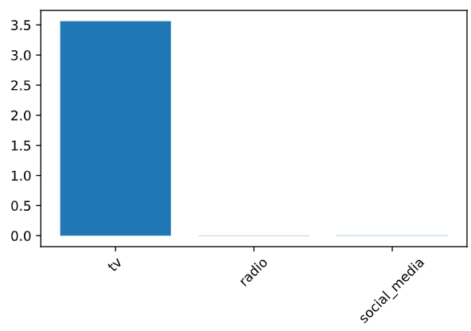

**Tuning Model**

#### Assessing perfomance

* Precision:

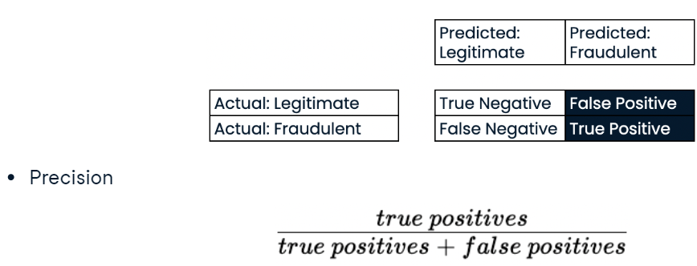

* The **F1-score** is the harmonic mean of precision and recall:

*The F1 score favors models with similar precision and recall, and is a useful metric if we are seeking a model which performs reasonably well across both metrics.*

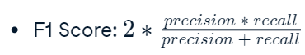

* Code for **assessing perfomance**:

from sklearn.metrics import confusion_matrix, classification_report

knn = KNeighborsClassifier(n_neighbors=6)

knn.fit(X_train, y_train)

y_pred = knn.predict(X_test)

print(classification_report(y_test, y_pred))

print(confusion_matrix(y_test, y_pred))

result:

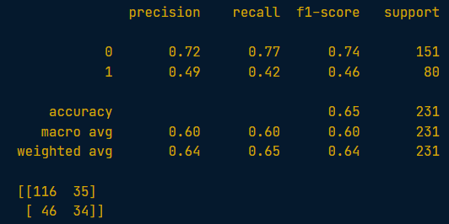

#### Logistic regression and the ROC curve

* Predicting probs in log_reg:

from sklearn.linear_model import LogisticRegression

logreg = LogisticRegression()

logreg.fit(X_train, y_train)

y_pred_probs = logreg.predict_proba(X_test)[:, 1]

print(y_pred_probs[:10])

result:



* Receiver operating characteristic (ROC curve) – visualize how the true positive rate and false positive rate vary as the decision threshold changes:

from sklearn.metrics import roc_curve

fpr, tpr, thresholds = roc_curve(y_test, y_pred_probs)

plt.plot([0, 1], [0, 1], 'k--')

plt.plot(fpr, tpr)

plt.xlabel('False Positive Rate')

plt.ylabel('True Positive Rate')

plt.title('ROC Curve for Diabetes Prediction')

plt.show()

result:

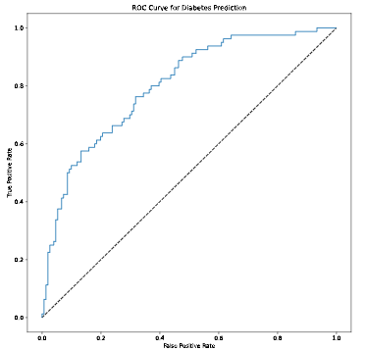

* AUC_ROC – calculate the area under the **ROC** curve:

from sklearn.metrics import roc_auc_score

print(roc_auc_score(y_test, y_pred_probs))

print(confusion_matrix(y_test, y_pred))

print(classification_report(y_test, y_pred))

result:

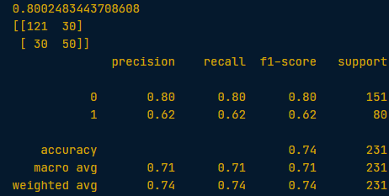

#### Hyperparameter tuning

* What is it?

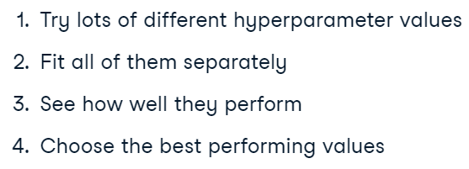

* What to do?

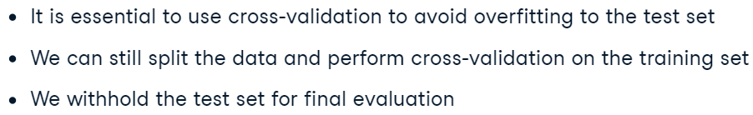

* GridSearch:
  + Code:

from sklearn.model_selection import GridSearchCV

param_grid = {'alpha':np.linspace(0.00001, 1, 20)}

lasso_cv = GridSearchCV(lasso, param_grid, cv=kf)

lasso_cv.fit(X_train, y_train)

print("Tuned lasso paramaters: {}".format(lasso_cv.best_params_))

print("Tuned lasso score: {}".format(lasso_cv.best_score_))

* + - Best_params_ – gives the best param for model to give the best fit;
    - Best_score_ – the best score of the model.

result:

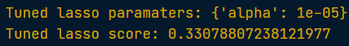

* + Limits:

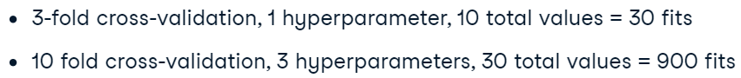

* RandomizedSearch:

params = {"penalty": ['l1', 'l2'],

         "tol": np.linspace(0.0001, 1, 50),

         "C": np.linspace(0.1, 1, 50),

         'class_weight':['balanced', {0:0.8,

                                      1:0.2}]}

logreg_cv = RandomizedSearchCV(logreg, params, cv=kf, n_iter=300)

logreg_cv.fit(X_train, y_train)

print("Tuned Logistic Regression Parameters: {}".format(logreg_cv.best_params_))

print("Tuned Logistic Regression Best Accuracy Score: {}".format(logreg_cv.best_score_))

* N_iter – number of hyperparameter tested;
* "penalty": ['l1', 'l2']: Определяет тип регуляризации (L1 или L2);
* "tol": np.linspace(0.0001, 1, 50): Задает точность останова для оптимизации;
* "C": np.linspace(0.1, 1, 50): Определяет силу регуляризации (чем меньше C, тем сильнее регуляризация);
* 'class_weight':['balanced', {0:0.8, 1:0.2}]: Устанавливает веса классов: 'balanced' автоматически учитывает дисбаланс классов, второй вариант задает веса явно.

result:



### Preprocessing and Pipelines

#### Preprocessing data

* Dealing with categories:

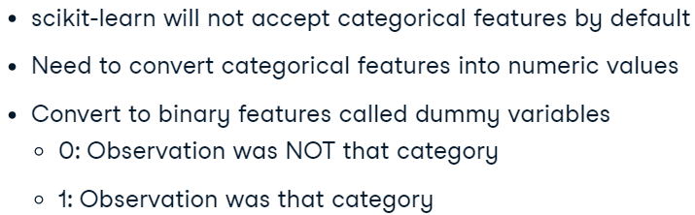

* How to get dummies:

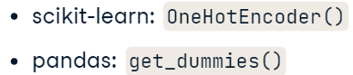

* How to create dummies:

music_dummies = pd.get_dummies(music_df, drop_first=True)

* + Drop_first – если два из них равны 0, то третий обязательно будет равен 1.
* Assessing model using **NEG_MSE and SQRT**:

X = music_dummies.drop('popularity', axis=1).values

y = music_dummies['popularity'].values

ridge = Ridge(alpha=0.2)

scores = cross_val_score(ridge,

                        X, y,

                        cv=kf,

                        scoring='neg_mean_squared_error')

rmse = np.sqrt(-scores)

print("Average RMSE: {}".format(np.mean(rmse)))

print("Standard Deviation of the target array: {}".format(np.std(y)))

result:



* + Explonation:

An average RMSE of approximately 8.24 is lower than the standard deviation of the target variable (song popularity), suggesting the model is reasonably accurate.

#### Handling missing data

* Remove missing data, which is 5% of the all data:

print(music_df.isna().sum().sort_values())

p = music_df.isna().sum()

m = music_df.columns[p<=len(music_df)*0.05]

music_df.dropna(subset=m, inplace=True)

music_df["genre"] = np.where(music_df["genre"]

            .str.contains('Rock'), 1, 0)

print(music_df.isna().sum().sort_values())

print("Shape of the `music_df`: {}".format(music_df.shape))

##### Imputing data:

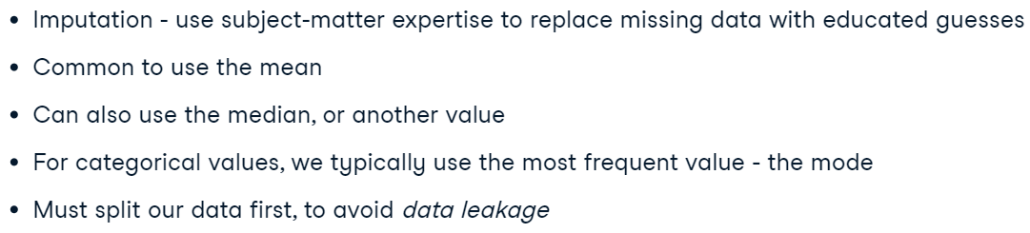

* + Imputing categories:

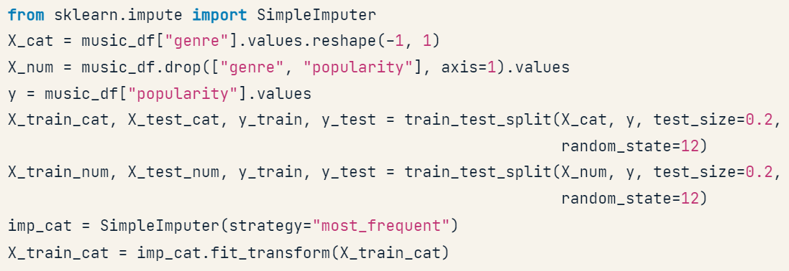

* + - Fit and transform **Train** features;
    - Transform **Test** features.
  + Imputing numeric values:

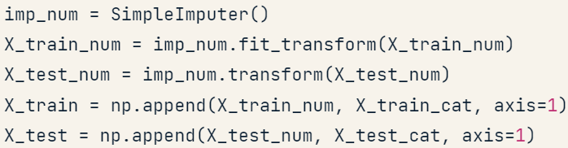

##### Pipeline

We can also impute using a pipeline, which is an object used to run a series of transformations and build a model in a single workflow.

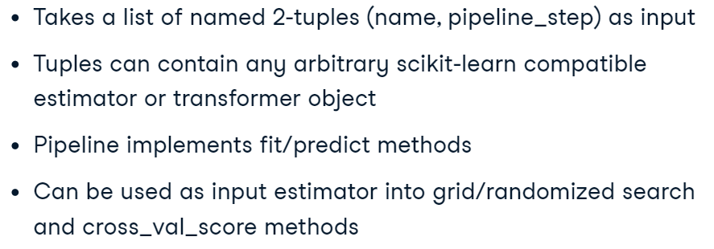

from sklearn.impute import SimpleImputer

from sklearn.pipeline import Pipeline

imputer = SimpleImputer()

knn = KNeighborsClassifier(n_neighbors=3)

steps = [('imputer', imputer), ('knn', knn)]

pipeline = Pipeline(steps)

pipeline.fit(X_train, y_train)

y_pred = pipeline.predict(X_test)

print(confusion_matrix(y_test, y_pred))

print(pipeline.score(X_test, y_test))

result:

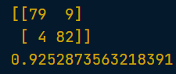

#### Centering and scaling

* Why we need it?

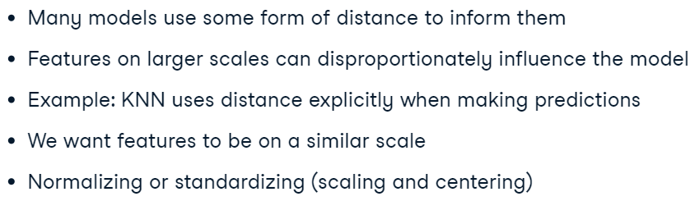

* + To eliminate these diff:

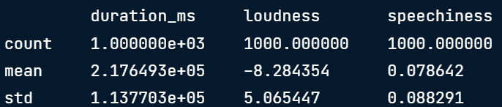

* How to scale?

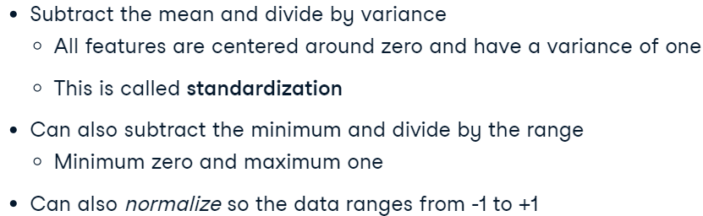

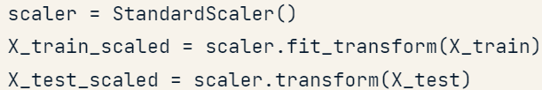

* Scaling in a pipeline:

from sklearn.preprocessing import StandardScaler

steps = [('scaler', StandardScaler()),

        ('lasso', Lasso(alpha=0.5))]

pipeline = Pipeline(steps)

pipeline.fit(X_train, y_train)

print(pipeline.score(X_test, y_test))

result:

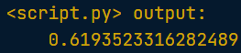

* Crossvalidation and scaling and Hyp_Par:

The "C" parameter in logistic regression – is a regularization parameter that controls the inverse of the regularization strength. In logistic regression, regularization is used to prevent overfitting by penalizing large coefficients.

The regularization term in logistic regression is typically of the form:

steps = [('scaler', StandardScaler()),

         ('logreg', LogisticRegression())]

pipeline = Pipeline(steps)

parameters = {'logreg__C': np.linspace(0.001, 1.0, 20)}

X_train, X_test, y_train, y_test = train_test_split(X, y,

                                                    test_size=0.2,

                                                    random_state=21)

cv = GridSearchCV(pipeline, param_grid=parameters)

cv.fit(X_train, y_train)

print(cv.best_score_, "\n", cv.best_params_)

result:

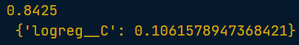

#### Evaluating multiple models

* Different models for different problems:

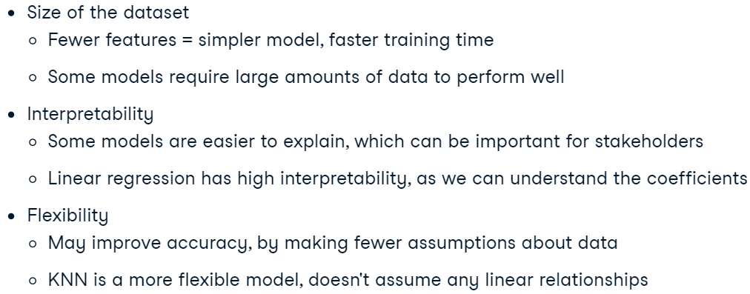

* How to assess:

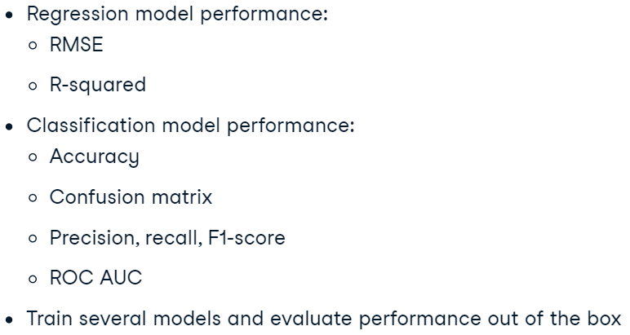

* + Out of the box – without hyperparameter tuning
* Assessing **Regression** model perfomance via viz:

models = {"Linear Regression": LinearRegression(),

          "Ridge": Ridge(alpha=0.1),

          "Lasso": Lasso(alpha=0.1)}

results = []

for i in models.values():

  kf= KFold(n_splits=6, shuffle=True, random_state=42)

  score = cross_val_score(i, X, y, cv=kf)

  results.append(score)

plt.boxplot(results, labels=models.keys())

plt.show()

result:

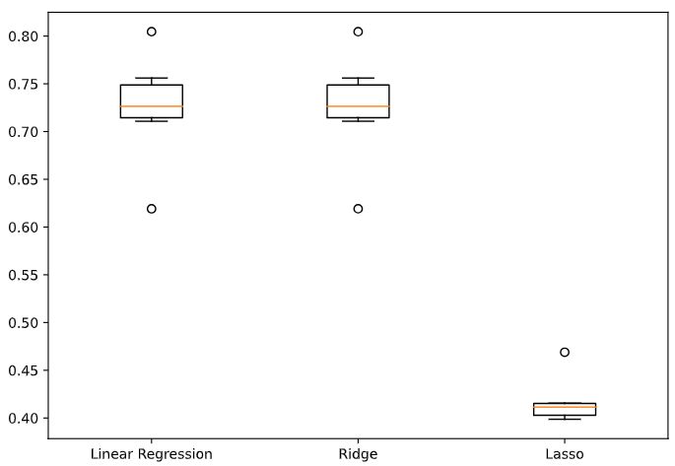

* Assessing perfomace of the best models:

from sklearn.metrics import mean_squared_error

for name, model in models.items():

  model.fit(X_train_scaled, y_train)

  y_pred = model.predict(X_test_scaled)

  test_rmse = mean_squared_error(y_test, y_pred, squared=False)

  print("{} Test Set RMSE: {}".format(name, test_rmse))

result:

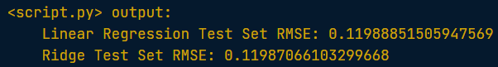

* Assessing **Classification** model perfomance:

models = {'Logistic Regression': LogisticRegression(),

          'KNN': KNeighborsClassifier(),

          'Decision Tree Classifier': DecisionTreeClassifier()}

results = []

for model in models.values():

  kf = KFold(n_splits=6,

            shuffle=True,

            random_state=12)

  score = cross_val_score(model,

                          X_train_scaled,

                          y_train,

                          cv=kf)

  results.append(score)

plt.boxplot(results, labels=models.keys())

plt.show()

result:

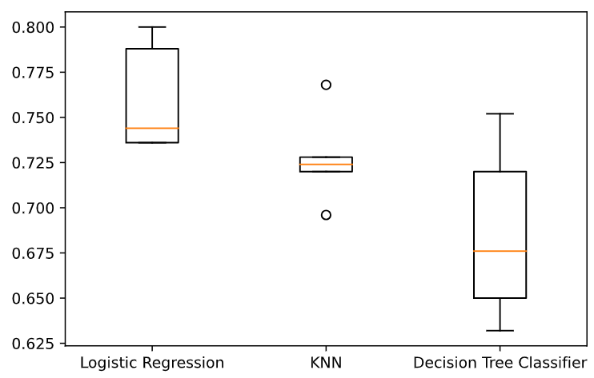

* **LogReg** imputing, scaling, cross_val:

steps = [('imp_mean', SimpleImputer()),

         ('scaler', StandardScaler()),

         ('logreg', LogisticRegression())]

pipeline = Pipeline(steps)

params = {"logreg__solver": ["newton-cg", "saga", "lbfgs"],

         "logreg__C": np.linspace(0.001, 1.0, 10)}

tuning = GridSearchCV(pipeline,

                param_grid=params)

tuning.fit(X_train, y_train)

y_pred = tuning.predict(X_test)

print("Tuned Logistic Regression Parameters: {}, Accuracy: {}".format(tuning.best_params_, tuning.score(X_test, y_test)))

result:



## Unsupervised Learning

### Clustering

#### Basics

* Supervised VS unsupervised?

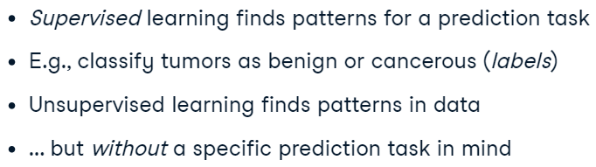

* Code

from sklearn.cluster import KMeans

model = KMeans(n_clusters=3)

model.fit(points)

labels = model.predict(new_points)

print(labels)

* Viz:

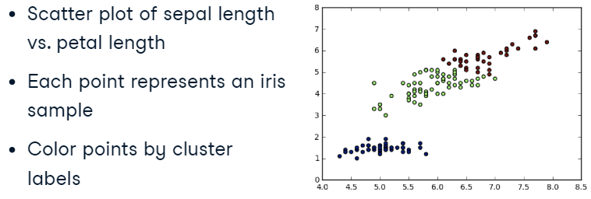

* Viz and clustering:

labels = model.predict(new_points)

xs = new_points[:, 0]

ys = new_points[:, 1]

plt.scatter(xs, ys,

            c=labels,

            alpha=0.5)

centroids = model.cluster_centers_

centroids_x = centroids[:, 0]

centroids_y = centroids[:, 1]

plt.scatter(centroids_x,

            centroids_y,

            marker='D',

            s=50)

plt.show()

result:

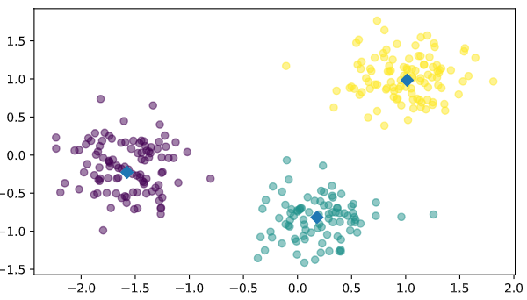

#### Evaluating a clustering

* What to do:

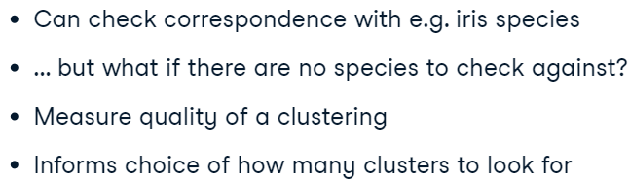

* How to evaluate:

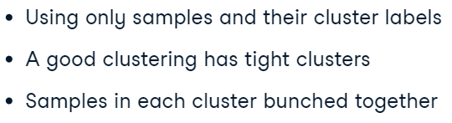

* + How the points of the cluster spread:

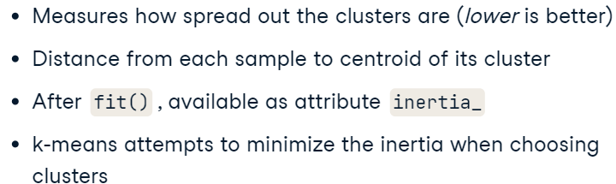

* How many clusters to choose:

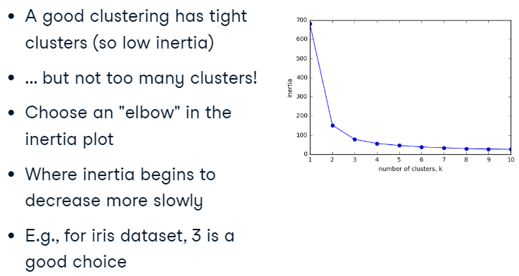

* Code:

ks = range(1, 6)

inertias = []

for k in ks:

    model = KMeans(n_clusters=k)

    model.fit(samples)

    inertias.append(model.inertia_)

plt.plot(ks, inertias, '-o')

plt.xlabel('number of clusters, k')

plt.ylabel('inertia')

plt.xticks(ks)

plt.show()

* + Model.inertia_ – assess the model.

result:

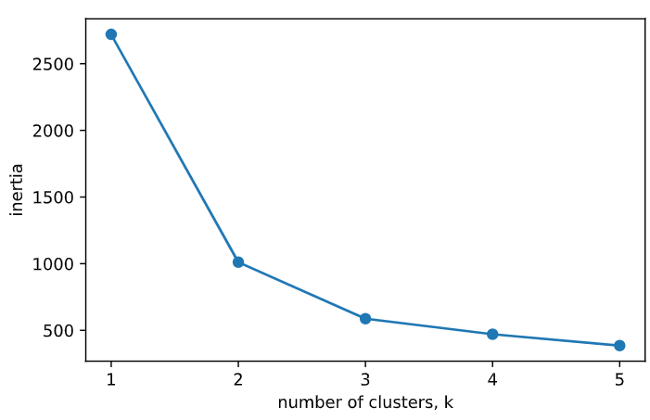

* Evaluating on our own how this works out:

model = KMeans(n_clusters=3)

labels = model.fit_predict(samples)

df = pd.DataFrame({'labels':labels,

                    'varieties':varieties})

ct = pd.crosstab(df['labels'],

                 df['varieties'])

print(ct)

result:

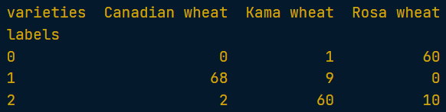

* Evaluate clusters usig elbow method:

from yellowbrick.cluster import KElbowVisualizer  
  
  
# Instantiate the clustering model and visualizer  
km_model = KMeans()  
visualizer = KElbowVisualizer(km_model, k=(2,10))  
  
visualizer.fit(df_rfmt) # Fit the data to the visualizer  
visualizer.show()

result:

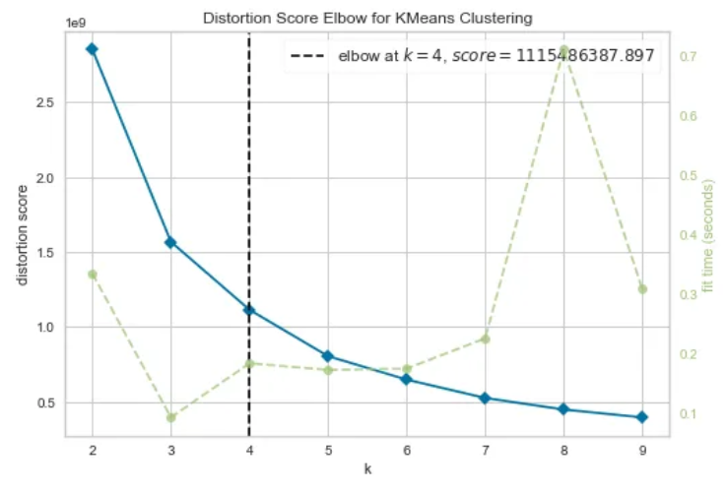

#### Transforming features for better clusterings

##### StandardScaler and Pipeline

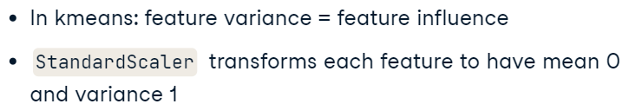

* Types:
  + StandardScaler() standardizes **features** (such as the features of the fish data from the previous exercise) by removing the mean and scaling to unit variance,
  + Normalizer() rescales **each sample** - here, each company's stock price - independently of the other.
  + MaxAbsScaler() масштабирует каждый признак путем деления его на максимальное абсолютное значение в данном признаке.
* StandardScaler:

from sklearn.pipeline import make_pipeline

from sklearn.preprocessing import StandardScaler

from sklearn.cluster import KMeans

scaler = StandardScaler()

kmeans = KMeans(n_clusters=4)

pipeline = make_pipeline(scaler, kmeans)

pipeline.fit(samples)

labels = pipeline.predict(samples)

df = pd.DataFrame({'labels':labels,

                    'species':species})

ct = pd.crosstab(df['labels'],

                df['species'])

print(ct)

result:

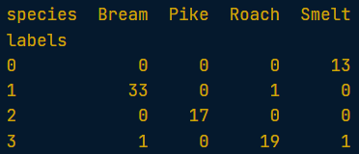

* Normalizer:

from sklearn.preprocessing import Normalizer

normalizer = Normalizer()

kmeans = KMeans(n_clusters=10)

pipeline = make_pipeline(normalizer, kmeans)

pipeline.fit(movements)

labels = pipeline.predict(movements)

df = pd.DataFrame({'labels':labels,

                    'companies':companies})

print(df.sort_values('labels'))

result:

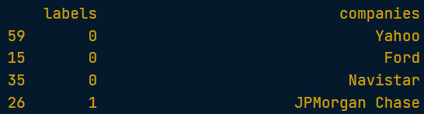

### Hierarchical Clustering and t-SNE

* Types:

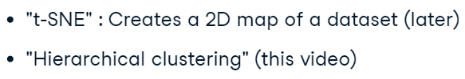

#### Visualizing hierarchies

* Process:

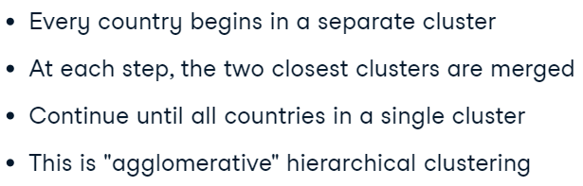

* Dendrogram with “complete” method:

from scipy.cluster.hierarchy import linkage, dendrogram

from sklearn.preprocessing import normalize

normalized_movements = normalize(movements)

mergings = linkage(normalized_movements,

                    method='complete')

dendrogram(mergings,

            labels=companies,

            leaf_rotation=90,

            leaf_font_size=6)

plt.show()

result:

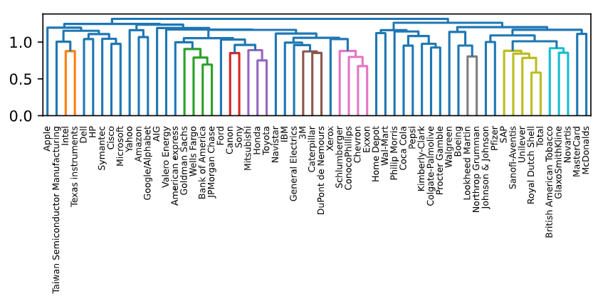

* Dendrogram with “single” method:

import matplotlib.pyplot as plt

from scipy.cluster.hierarchy import linkage, dendrogram

mergings = linkage(samples, method='single')

dendrogram(

    mergings,

    labels=country_names,

    leaf_rotation=90,

    leaf_font_size=6

)

plt.show()

#### Cluster labels in hierarchical clustering

* Cluster distances:

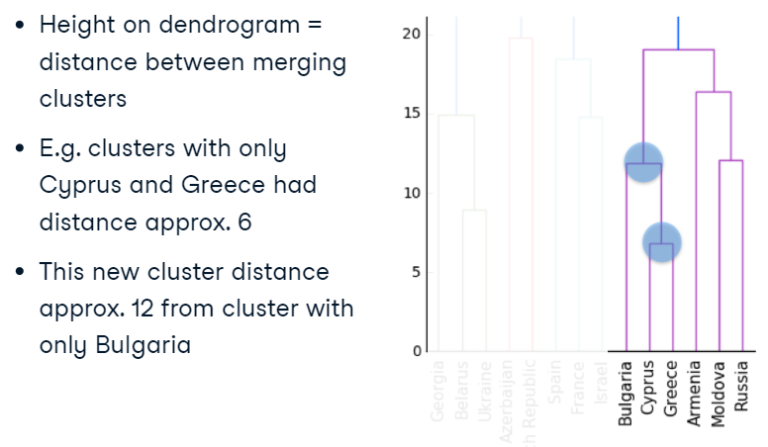

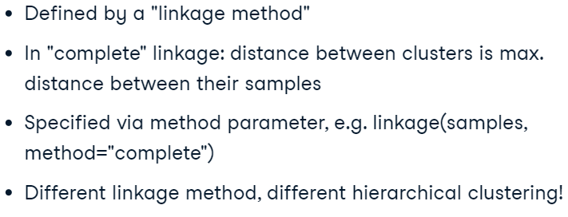

* + Explonation:

In complete linkage, the distance between clusters is the distance between the furthest points of the clusters. In single linkage, the distance between clusters is the distance between the closest points of the clusters.

* Code for extracting cluster labels:

import pandas as pd

from scipy.cluster.hierarchy import fcluster

labels = fcluster(mergings, 6, criterion='distance')

df = pd.DataFrame({'labels': labels, 'varieties': varieties})

ct = pd.crosstab(df['labels'],

                df['varieties'])

print(ct)

result:

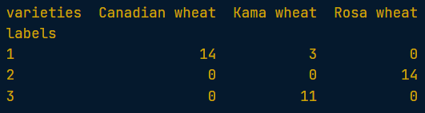

#### t-SNE for 2-dimensional maps

* What is it – you have to start it again each time:

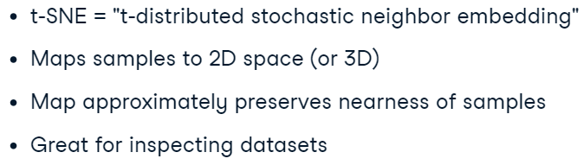

* Code:

from sklearn.manifold import TSNE

model = TSNE(learning_rate=200)

tsne_features = model.fit_transform(samples)

xs = tsne_features[:,0]

ys = tsne_features[:,1]

plt.scatter(xs, ys, c=variety_numbers)

plt.show()

result:

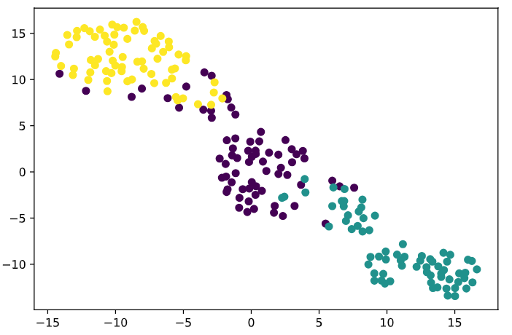

* Difference:

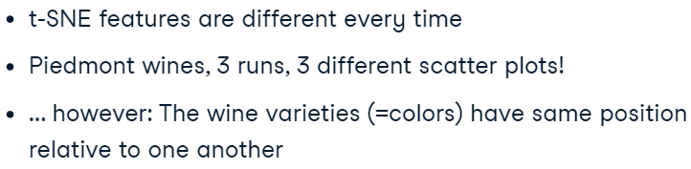

* Creating a map:

from sklearn.manifold import TSNE

model = TSNE(learning_rate=50)

tsne_features = model.fit_transform(normalized_movements)

xs = tsne_features[:,0]

ys = tsne_features[:,1]

plt.scatter(xs, ys, alpha=0.5)

for x, y, company in zip(xs, ys, companies):

    plt.annotate(company, (x, y), fontsize=5, alpha=0.75)

plt.show()

result:

https://campus.datacamp.com/courses/unsupervised-learning-in-python/visualization-with-hierarchical-clustering-and-t-sne?ex=12

### Decorrelating Your Data and Dimension Reduction

#### Visualizing the PCA transformation

* What is Dimension reduction:

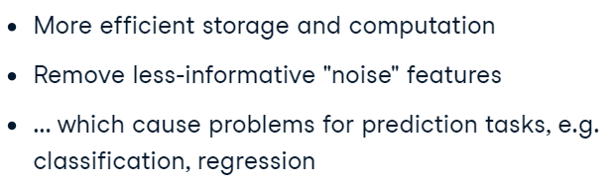

* What is PCA:

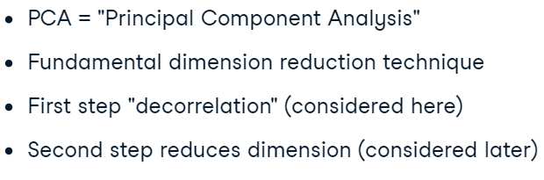

* PCA align data with axes:

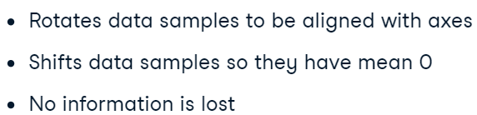

* Learning process:

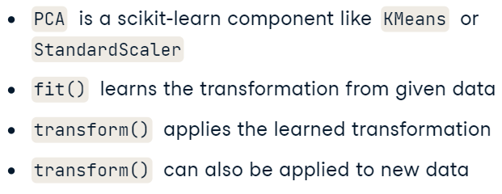

* PCA features:

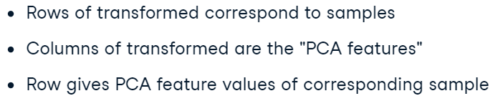

* Why is this Principal Components:

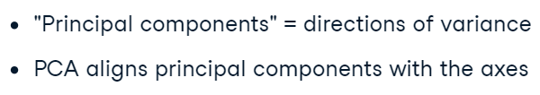

* Code for PCA decorrelation:

from sklearn.decomposition import PCA

model = PCA()

pca_features = model.fit_transform(grains)

xs = pca_features[:,0]

ys = pca_features[:,1]

plt.scatter(xs, ys)

plt.axis('equal')

plt.show()

correlation, pvalue = pearsonr(xs, ys)

print(correlation)

result:

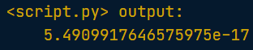

* Code for **principal** components:

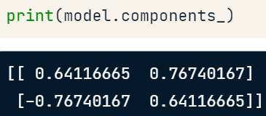

#### Intrinsic dimension

* What is it:

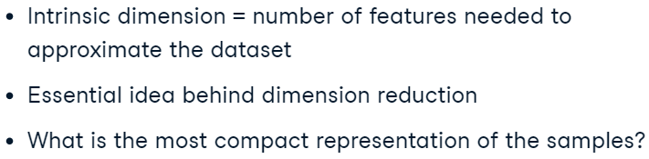

* + How PCA identifies them:

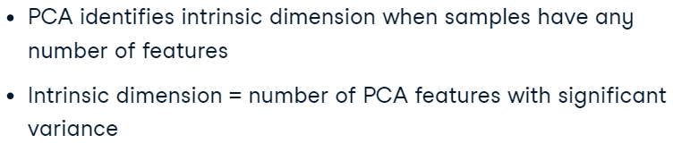

* Plotting first principal component:

plt.scatter(grains[:, 0], grains[:, 1], c='b')

model=PCA()

model.fit(grains)

mean = model.mean_

first_pc = model.components_[0, :]

plt.arrow(mean[0], mean[1],

        first_pc[0], first_pc[1],

        color='red', width=0.01)

plt.axis('equal')

plt.show()

result:

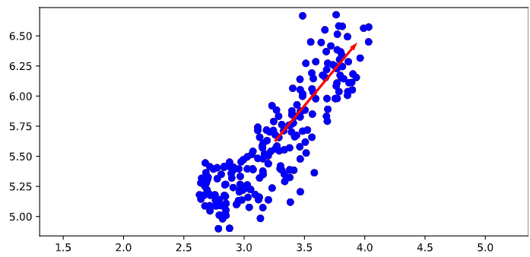

* Code:

from sklearn.preprocessing import StandardScaler

from sklearn.decomposition import PCA

from sklearn.pipeline import make_pipeline

import matplotlib.pyplot as plt

scaler = StandardScaler()

pca = PCA()

pipeline = make_pipeline(scaler, pca)

pipeline.fit(samples)

features = range(pca.n_components_)

plt.bar(features, pca.explained_variance_)

plt.xlabel('PCA feature')

plt.ylabel('variance')

plt.xticks(features)

result:

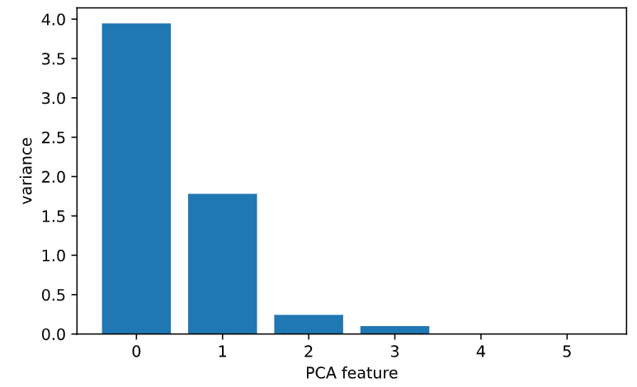

#### Dimension reduction with PCA

* Sparse matrix:

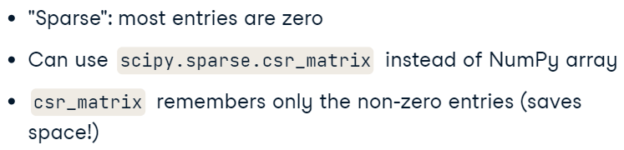

* Code for reduction:

from sklearn.decomposition import PCA

pca = PCA(n_components=2)

pca.fit(scaled_samples)

pca_features = pca.transform(scaled_samples)

print(pca_features.shape)

* Sparse matrix:

from sklearn.cluster import KMeans

from sklearn.decomposition import TruncatedSVD

from sklearn.pipeline import make_pipeline

svd = TruncatedSVD(n_components=50)

kmeans = KMeans(n_clusters=6)

pipeline = make_pipeline(svd, kmeans)

pipeline.fit(articles)

labels = pipeline.predict(articles)

df = pd.DataFrame({'label': labels, 'article': titles})

print(df.sort_values('label'))

result:

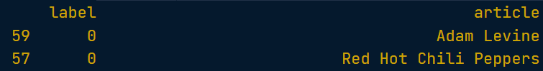

* Word frequency:

from sklearn.feature_extraction.text import TfidfVectorizer

tfidf = TfidfVectorizer()

csr_mat = tfidf.fit_transform(documents)

words = tfidf.get_feature_names()

print(words)

### Discovering Interpretable Features

* What is it:

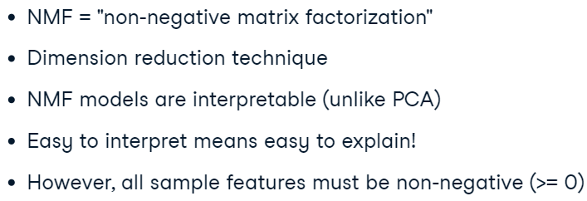

* Using NMF:

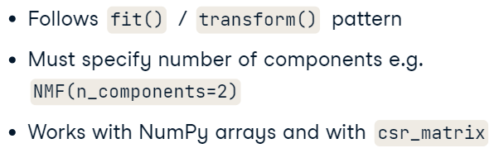

* tf-idf:

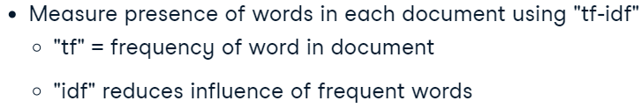

* NMF components:

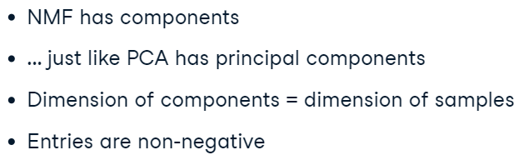

* Reconstruction of a sample:

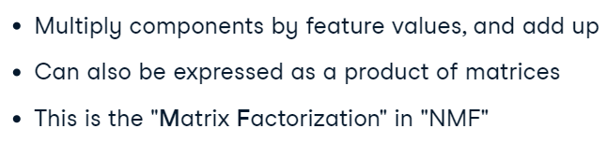

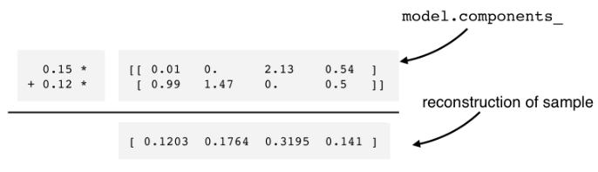

* Feature extraction:

pca_features = pca.transform(scaled_samples)

## Tree-Based Models

### Classification and Regression Trees

#### Decision tree for classification

* What is it?

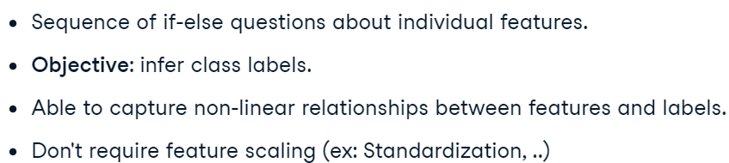

* Working process – asking questions:

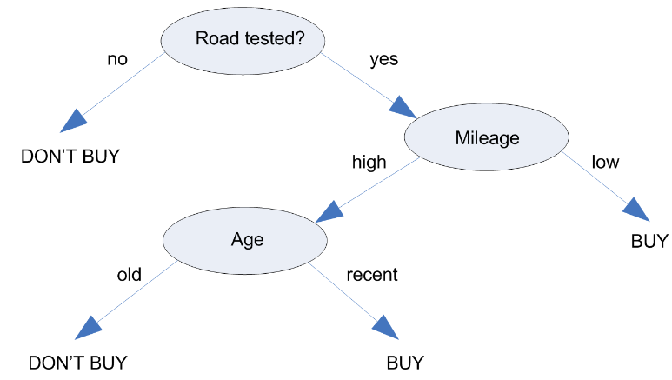

* How it works?

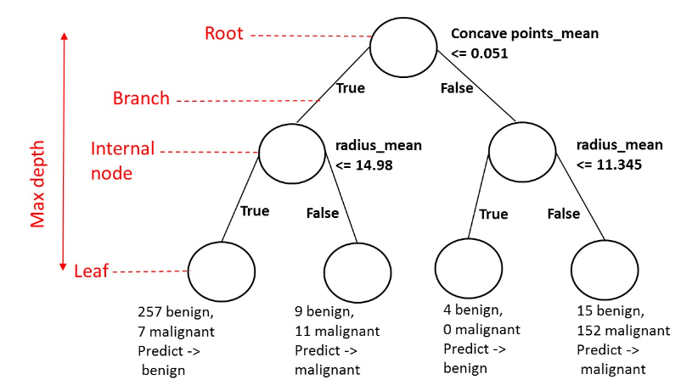

* + Example:

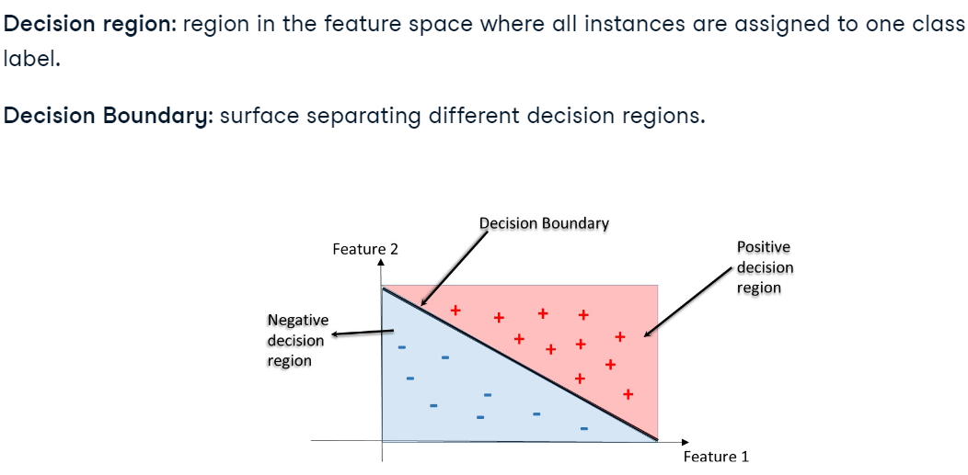

* Difference:

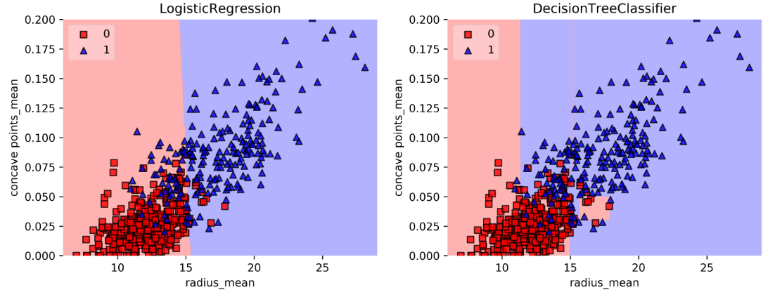

* Code for Tree Clasification:

from sklearn.tree import DecisionTreeClassifier

from sklearn.metrics import accuracy_score

dt = DecisionTreeClassifier(max_depth=6, random_state=SEED)

dt.fit(X_train, y_train)

y_pred = dt.predict(X_test)

acc = accuracy_score(y_test, y_pred)

print("Test set accuracy: {:.2f}".format(acc))

result:

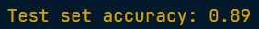

* Viz your descision-boundary:

from sklearn.linear_model import LogisticRegression

logreg = LogisticRegression(random_state=1)

logreg.fit(X_train, y_train)

clfs = [logreg, dt]

plot_labeled_decision_regions(X_test, y_test, clfs)

result:

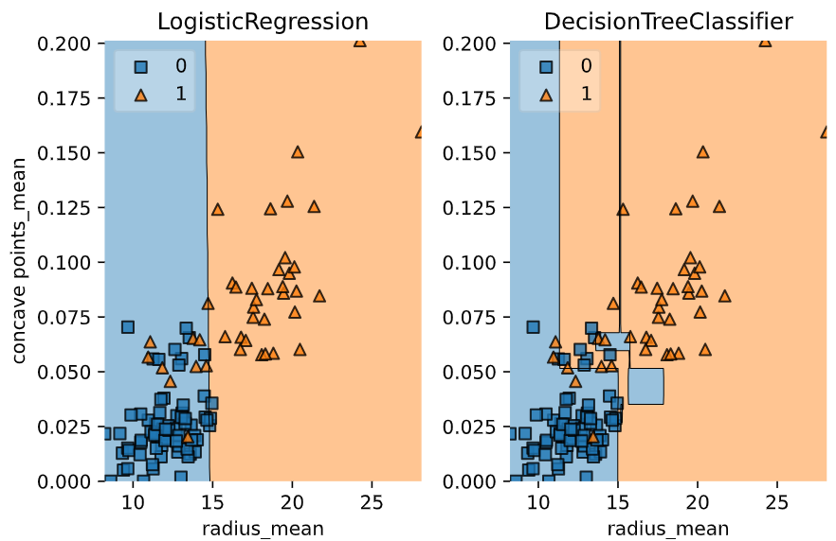

#### Classification tree Learning

* Builing blocks of DT:

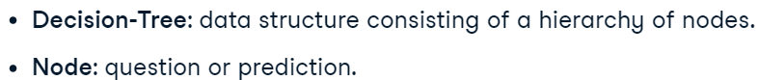

* Types of nodes:

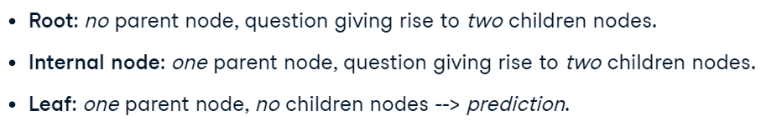

* + The leaf is built – the tree is trained in such a way so that, in each leaf, one class-label is predominant.
* **Information Gain**:

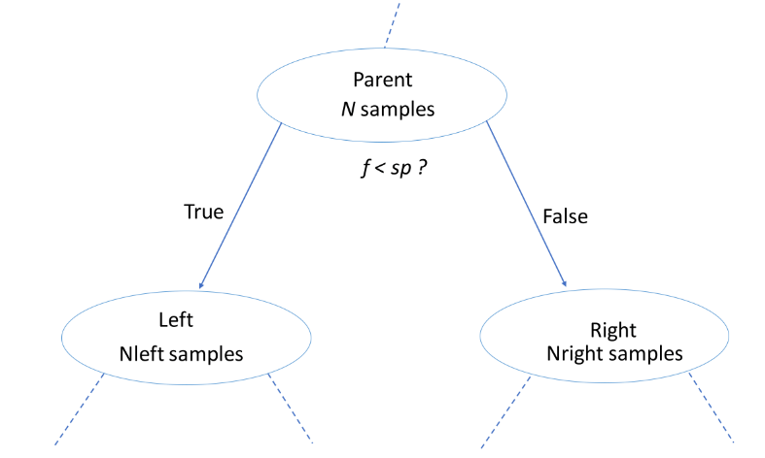

* + Formula:

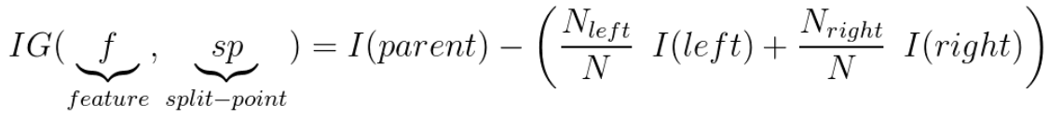

* + - Measuring **impurity** of the node:

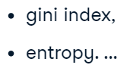

* How CT is learning:

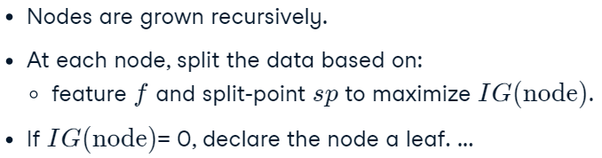

* Code:

from sklearn.tree import DecisionTreeClassifier

from sklearn.metrics import accuracy_score

dt_entropy = DecisionTreeClassifier(max_depth=8, random_state=1, criterion='entropy')

dt_entropy.fit(X_train, y_train)

y_pred = dt_entropy.predict(X_test)

accuracy_entropy = accuracy_score(y_test, y_pred)

print(f'Accuracy achieved by using entropy: {accuracy_entropy:.3f}')

print(f'Accuracy achieved by using the gini index: {accuracy_gini:.3f}')

result:

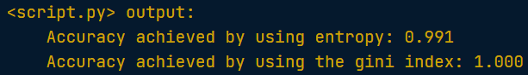

The **gini index** is slightly faster to compute and is the default criterion used in the DecisionTreeClassifier model of scikit-learn.

#### Decision tree for regression

* Information Criterion for Regression-Tree:

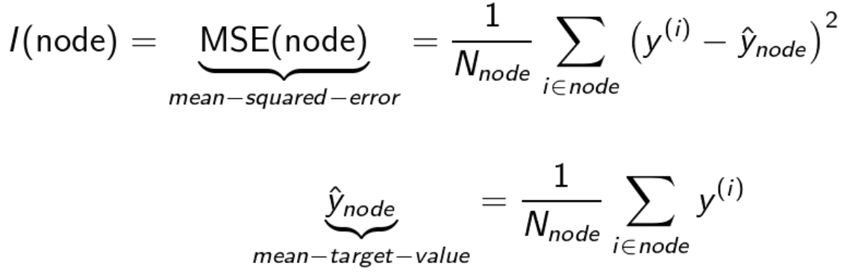

* + Explonation:

The regression tree tries to find the splits that produce leafs where in each leaf the target values are on average, the closest possible to the mean-value of the labels in that particular leaf.

* Prediction:

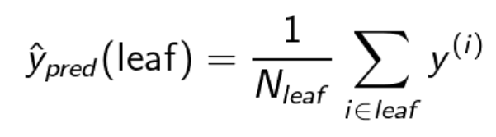

* Perfoming and assessing model:

from sklearn.tree import DecisionTreeRegressor

from sklearn.metrics import mean_squared_error

dt = DecisionTreeRegressor(

    max_depth=8,

    random_state=3,

    min_sample_leaf=0.13

)

dt.fit(X_train, y_train)

y_pred = dt.predict(X_test)

mse_dt = mean_squared_error(y_test, y_pred)

rmse_dt = mse_dt**0.5

print("Test set RMSE of dt: {:.2f}".format(rmse_dt))

* + min_sample_leaf – imposes a stopping condition in which each leaf has to contain at least 13% of the training data.

For example, if min_samples_leaf is set to 5, it means that each leaf node in the tree must contain at least 5 samples. If a potential split would result in a leaf node with fewer than 5 samples, the split will not be performed, and the algorithm will consider other split options.

result:

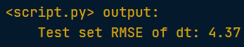

### The Bias-Variance Tradeoff

#### Generalization Error

* The goal:

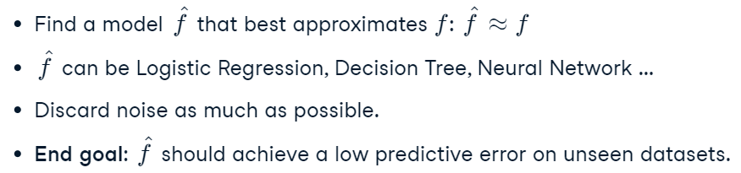

* Over- and underfitting:

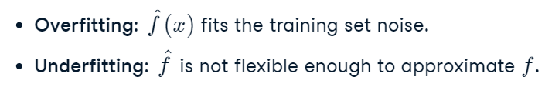

* + Overfitting:

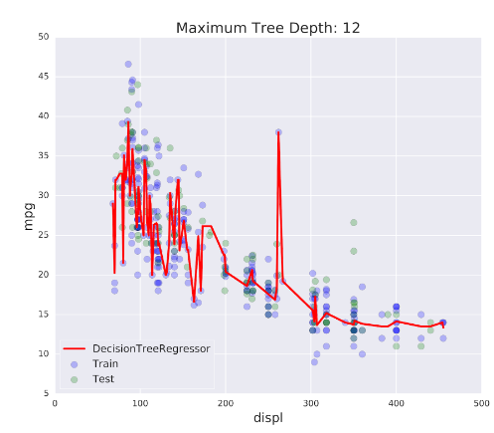

* + Underfitting:

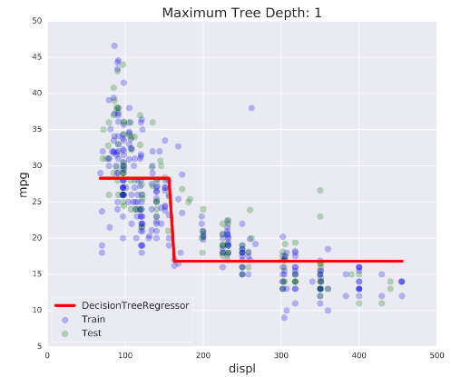

* **Generalization Error**:

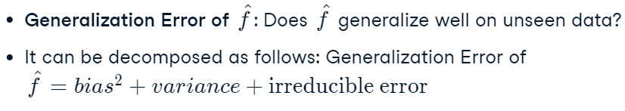

* + Bias – high measure lead to underfitting:

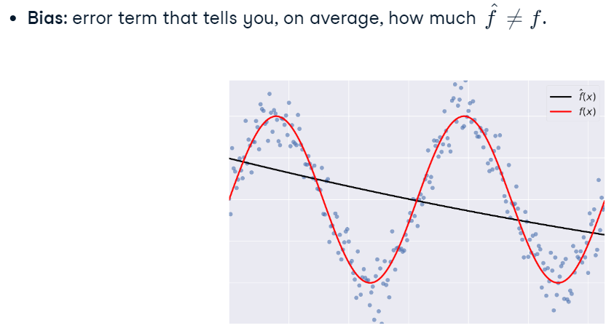

* + Variance – high measure lead to overfitting:

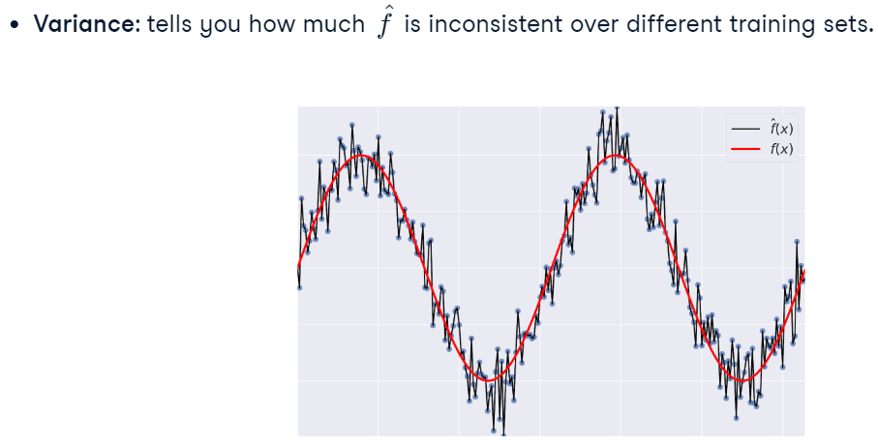

* Bias-Variance Tradeoff:

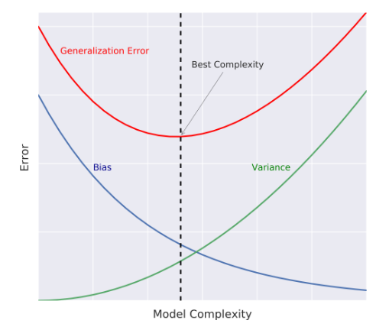

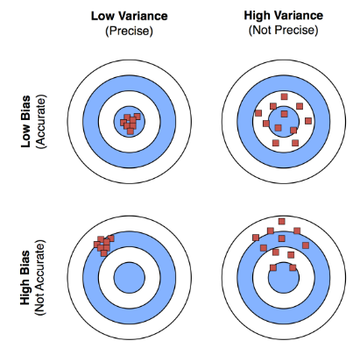

#### Diagnose bias and variance problems

* Estimating the Generalization error:

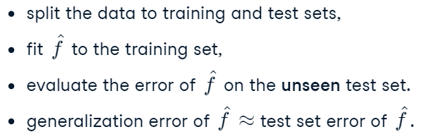

* Evaluating model:

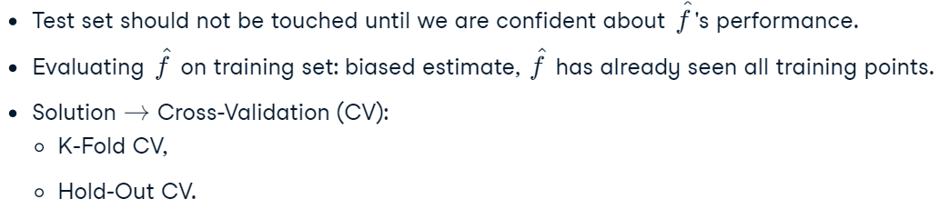

* Variance problem:

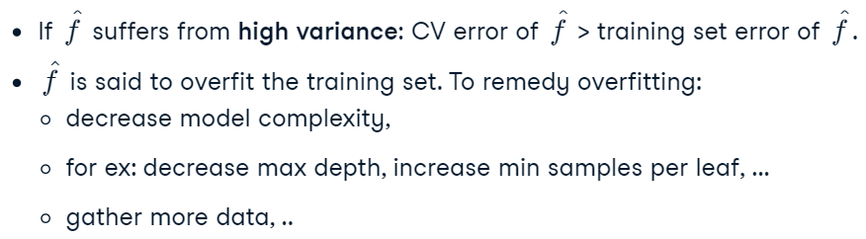

* Bias problem:

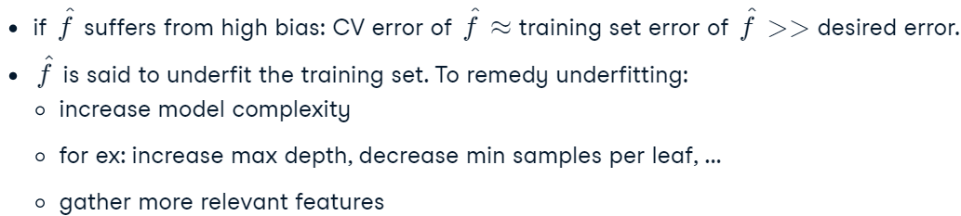

* + Desired error – dependent variable of your dataset
* Code – algo higher:

MSE_CV_scores = - cross_val_score(dt, X_train, y_train,

                                scoring='neg_mean_squared_error',

                                cv=10,

                                n_jobs=-1)

RMSE_CV = np.mean(MSE_CV_scores) ** 0.5

print('CV RMSE: {:.2f}'.format(RMSE_CV))

* + N_jobs – to use full potential of CPU.

result:

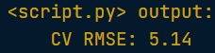

* Assessing perfomance of training data:

from sklearn.metrics import mean_squared_error as MSE

dt.fit(X_train, y_train)

y_pred_train = dt.predict(X_train)

RMSE_train = MSE(y_train, y_pred_train, squared=False)

print('Train RMSE: {:.2f}'.format(RMSE_train))

result:

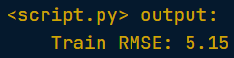

#### Ensemble Learning

* Advantages of CARTs:

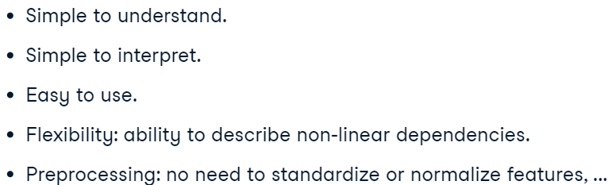

* Limitations:

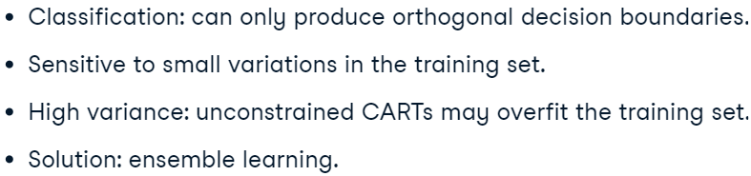

* **Ensemple Learning:**

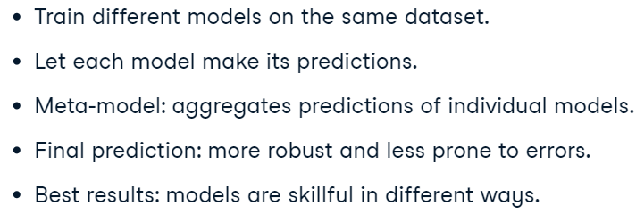

* How it works:

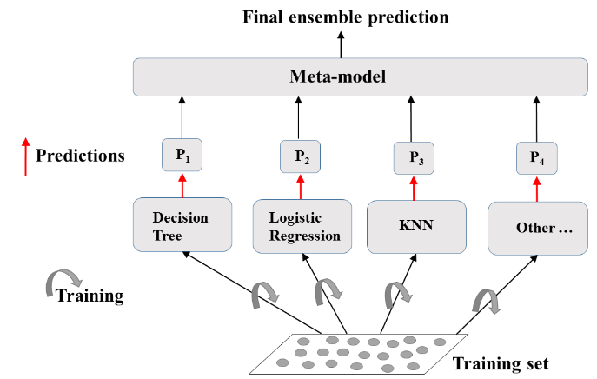

* Hard voting:

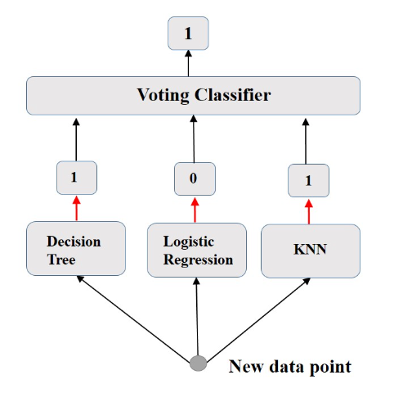

* Code for **esnsemble**:

classifiers = [('Logistic Regression', lr),

                ('K Nearest Neighbours', knn),

                ('Classification Tree', dt)]

for clf_name, clf in classifiers:

    clf.fit(X_train, y_train)

    y_pred = clf.predict(X_test)

    accuracy = accuracy_score(y_test, y_pred)

    print('{:s} : {:.3f}'.format(clf_name, accuracy))

result:

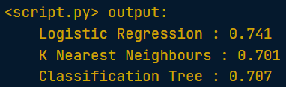

* Voting Classifier – ensemle several models:

from sklearn.ensemble import VotingClassifier

vc = VotingClassifier(estimators = classifiers)

vc.fit(X_train, y_train)

y_pred = vc.predict(X_test)

accuracy = accuracy_score(y_test, y_pred)

print('Voting Classifier: {:.3f}'.format(accuracy))

result:

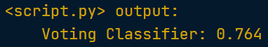

### Bagging and Random Forests

#### Bagging | Bootstrap

* What is it:

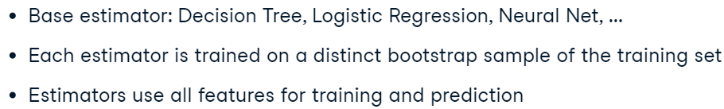

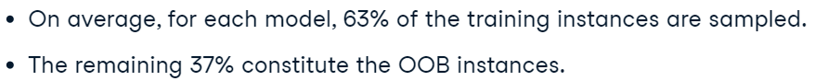

* How it works:

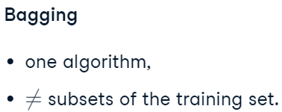

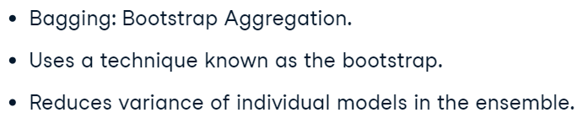

* How is it training:

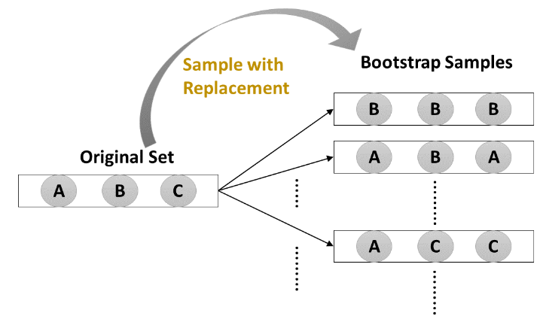

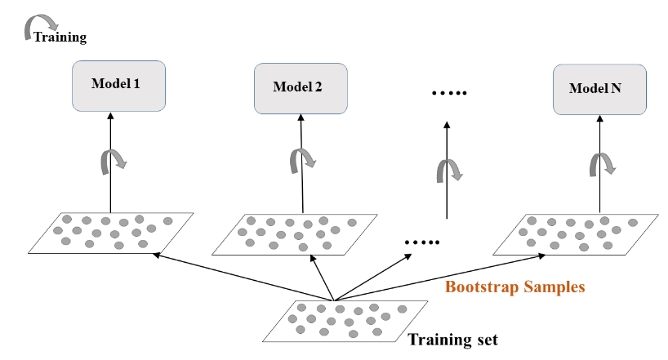

* + How it works:

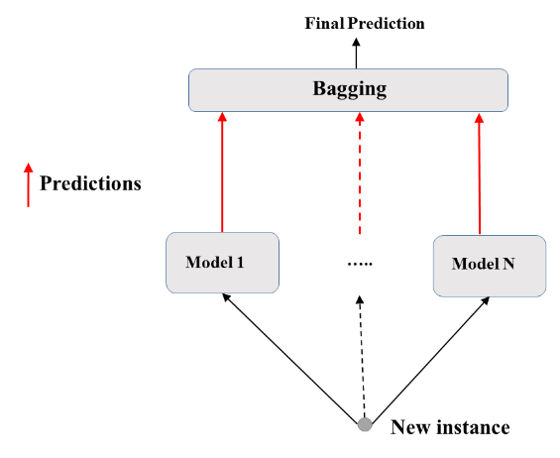

* Bagging for classification and regression:

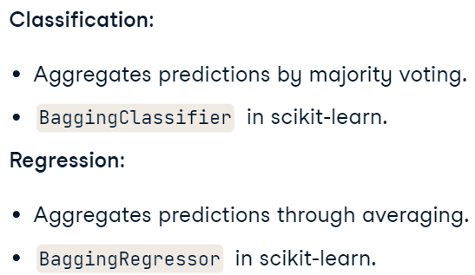

* Code:

from sklearn.tree import DecisionTreeClassifier

from sklearn.ensemble import BaggingClassifier

dt = DecisionTreeClassifier(random_state=1)

bc = BaggingClassifier(base_estimator=dt, n_estimators=50, random_state=1)

bc.fit(X_train, y_train)

y_pred = bc.predict(X_test)

acc_test = accuracy_score(y_test, y_pred)

print('Test set accuracy of bc: {:.2f}'.format(acc_test))

* + N_estimators – how many times it will be split

result:

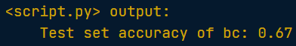

#### Out of Bag (OOB) Evaluation

* What is it:



* How it works:

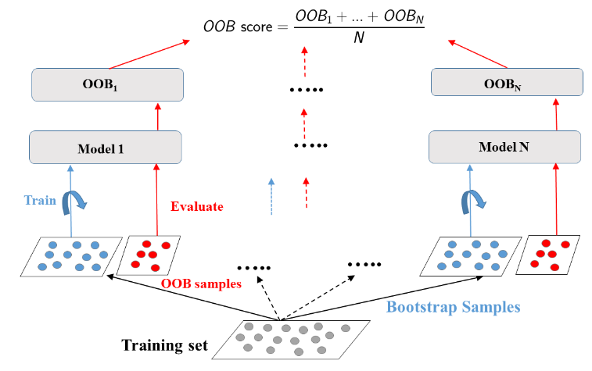

* + In sklearn, you can evaluate the OOB accuracy of an ensemble classifier by setting the parameter oob_score to True during instantiation. After training the classifier, the OOB accuracy can be obtained by accessing the .oob_score_ attribute from the corresponding instance.
  + The OOB-score *corresponds* to the accuracy for **classifiers** and the *r-squared* score for **regressors**.
* Comparing the OOB accuracy to the test set accuracy:

from sklearn.ensemble import BaggingClassifier

from sklearn.tree import DecisionTreeClassifier

dt = DecisionTreeClassifier(random_state=1, min_samples_leaf=8)

bc = BaggingClassifier(random_state=1,

                        oob_score=True,

                        n_estimators=50,

                        base_estimator=dt

bc.fit(X_train, y_train)

y_pred = bc.predict(X_test)

acc_test = accuracy_score(y_test, y_pred)

acc_oob = bc.oob_score_

print('Test set accuracy: {:.3f}, OOB accuracy: {:.3f}'.format(acc_test, acc_oob))

result:

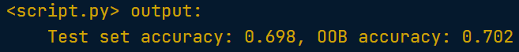

#### Random Forests

* **What is it**:

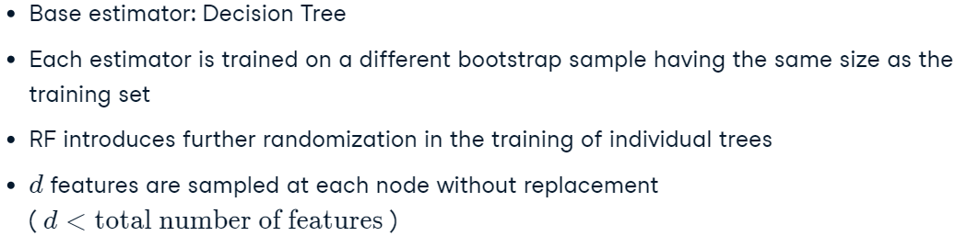

* The process:

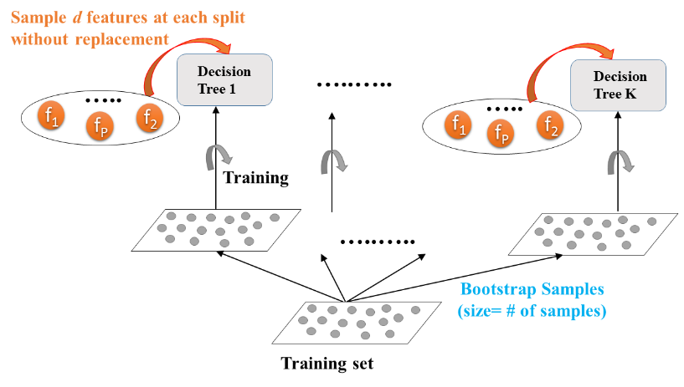

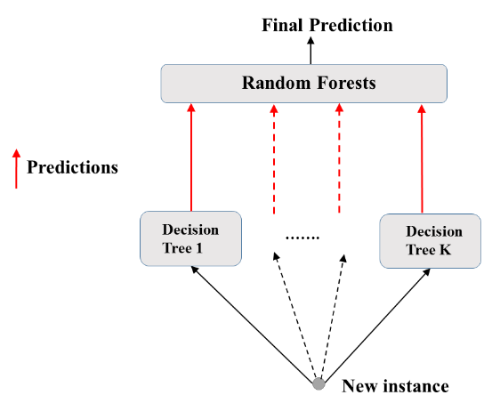

* + How it works:

D = to the square-root of the number of features. For example, if there are 100 features, only 10 features are sampled at each node.

* How prediction is made:

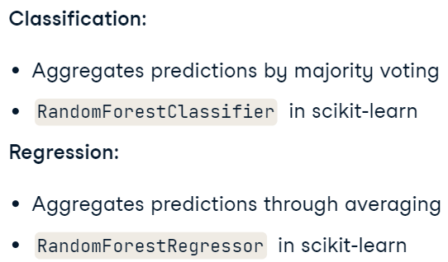

* Feature importance:

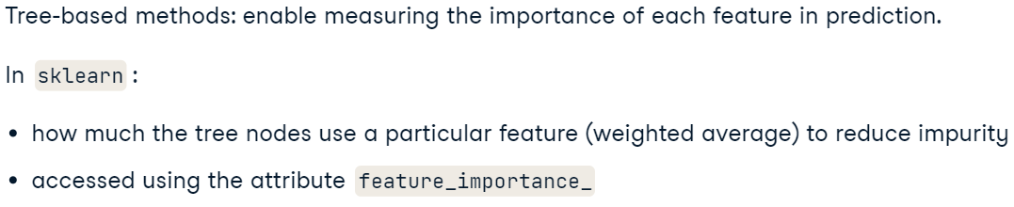

* Code:

from sklearn.ensemble import RandomForestRegressor

rf = RandomForestRegressor(random_state=2,

                            n_estimators=25,

                            min_samples_leaf=0.1)

rf.fit(X_train, y_train)

y_pred = rf.predict(X_test)

rmse_test = MSE(y_test, y_pred, squared=False)

print('Test set RMSE of rf: {:.2f}'.format(rmse_test))

result:

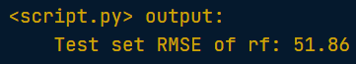

* Feature importance:

importances = pd.Series(data=rf.feature_importances_,

                        index=X_train.columns)

importances_sorted = importances.sort_values()

importances_sorted.plot(kind='barh',

        color='lightgreen')

plt.title('Features Importances')

plt.show()

result:

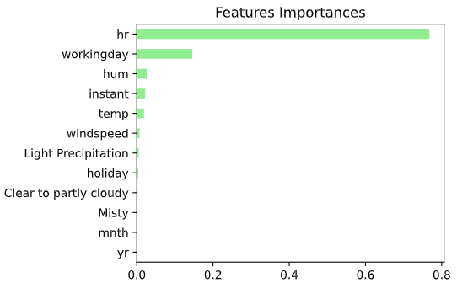

### Boosting

##### Basics

* What is it:

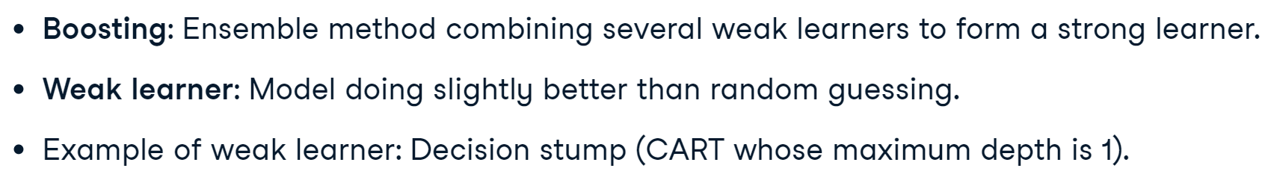

* How it works:

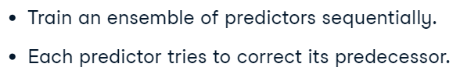

#### Adaboost

* How it works:

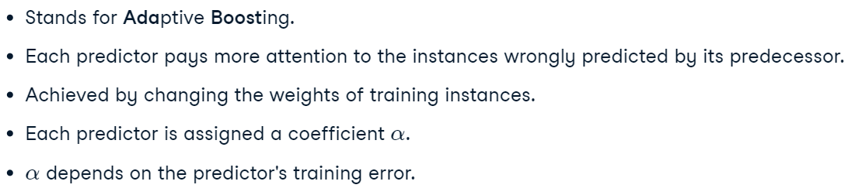

* Process:

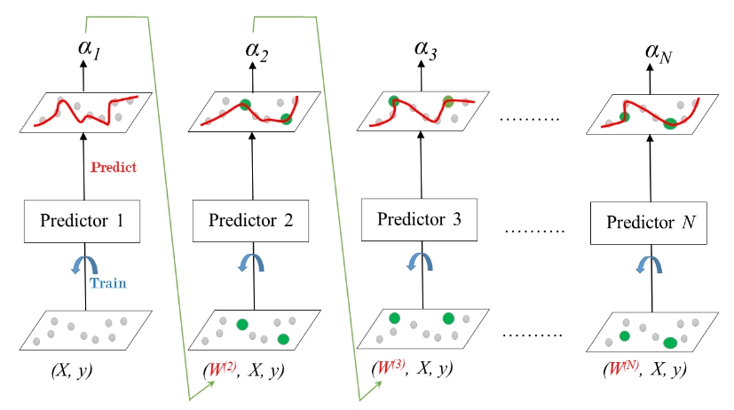

* Learning rate:

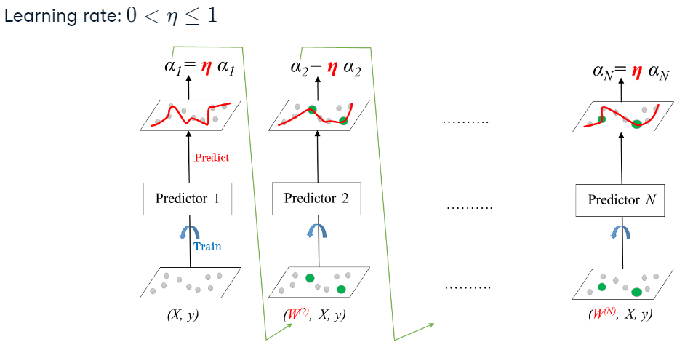

* + A trade-off – a smaller value of eta should be compensated by a greater number of estimators.
* Prediction:

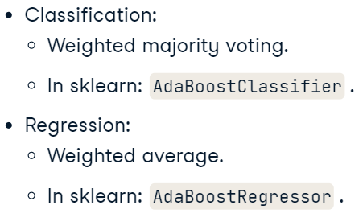

* Code:

from sklearn.tree import DecisionTreeClassifier

from sklearn.ensemble import AdaBoostClassifier

from sklearn.metrics import roc_auc_score

dt = DecisionTreeClassifier(random_state=1, max_depth=2)

ada = AdaBoostClassifier(base_estimator=dt,

                         n_estimators=180,

                         random_state=1)

ada.fit(X_train, y_train)

y_pred_proba = ada.predict_proba(X_test)[:, 1]

ada_roc_auc = roc_auc_score(y_test, y_pred_proba)

print('ROC AUC score: {:.2f}'.format(ada_roc_auc))

result:

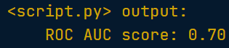

#### Gradient Boosting

* How it works:

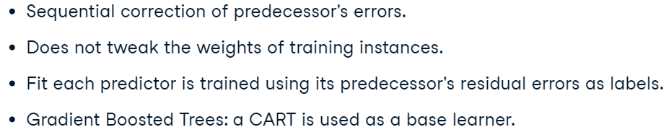

* Process:

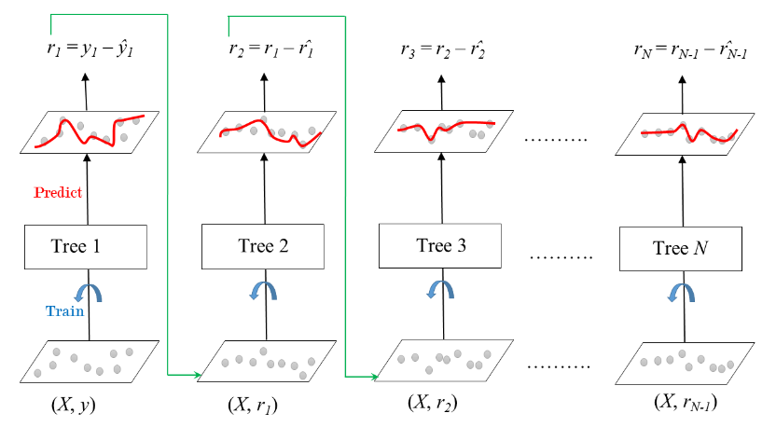

* Shrinkage (усадка):
  + The prediction of each tree in the ensemble is shrinked after it is multiplied by a learning rate eta which is a number between 0 and 1.
  + Trade-off: Decreasing the learning rate needs to be compensated by increasing the number of estimators in order for the ensemble to reach a certain performance.

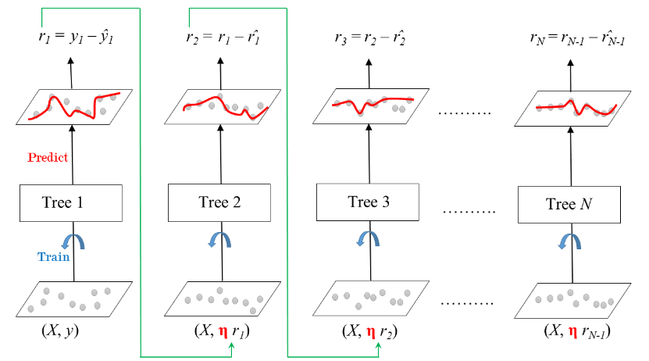

* Prediction:

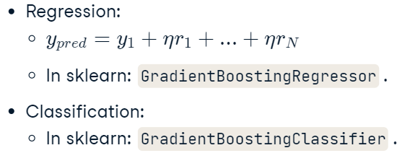

* Code:

from sklearn.ensemble import GradientBoostingRegressor

gb = GradientBoostingRegressor(max_depth=4,

                                n_estimators=200,

                                random_state=2)

gb.fit(X_train, y_train)

y_pred = gb.predict(X_test)

mse_test = MSE(y_test, y_pred)

rmse_test = mse_test ** 0.5

print('Test set RMSE of gb: {:.3f}'.format(rmse_test))

#### Stochastic Gradient Boosting

* How it works:

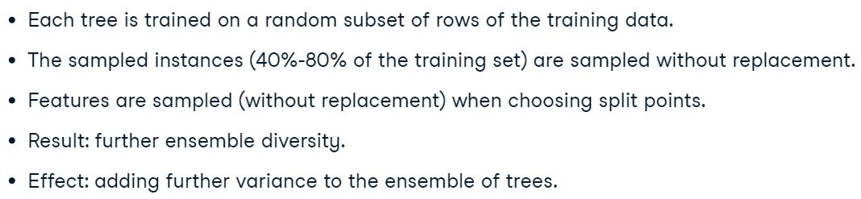

* The process:

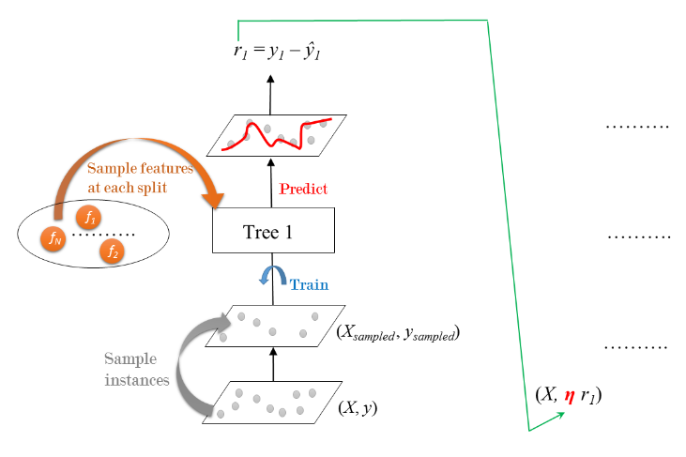

* Code:

sgbr = GradientBoostingRegressor(

    max_depth=4,

    n_estimators=200,

    subsample=0.9,

    max_features=0.75,

    random_state=2

)

sgbr.fit(X_train, y_train)

y_pred = sgbr.predict(X_test)

mse_test = MSE(y_test, y_pred)

rmse_test = mse_test**0.5

print('Test set RMSE of sgbr: {:.3f}'.format(rmse_test))

* + Subsemple – samples X% of the data for training;
  + Max_features – each tree uses X% of available features to perform the best-split.

Result:

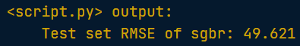

### Model Tuning

##### Tuning a CART's Hyperparameters

* Examples:

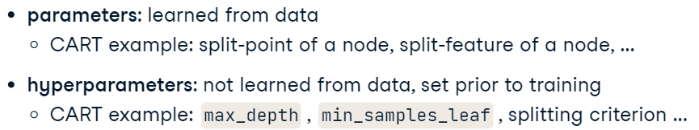

* How it works:

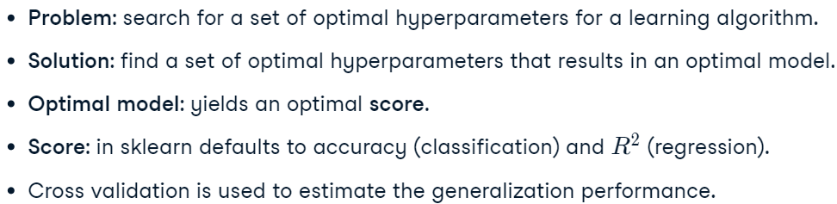

* Process:

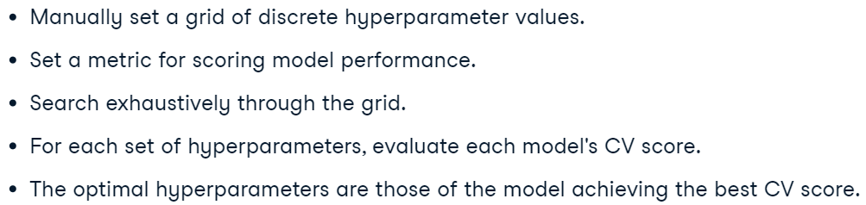

* Get params for tuning:

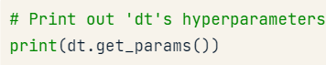

* Code:

params_dt = {

    'max_depth':[2, 3, 4],

    'min_samples_leaf':[0.12, 0.14, 0.16, 0.18]

}

grid_dt = GridSearchCV(estimator=dt,

                        param_grid=params_dt,

                        scoring='roc_auc',

                        cv=5,

                        n_jobs=-1)

best_model = grid_dt.best_estimator_

y_pred_proba = best_model.predict_proba(X_test)[:, 1]

test_roc_auc = roc_auc_score(y_test, y_pred_proba)

print('Test set ROC AUC score: {:.3f}'.format(test_roc_auc))

result:

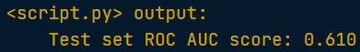

##### Tuning a RF's Hyperparameters

* Code:

from sklearn.model_selection import GridSearchCV

params_rf = {

    'n_estimators':[100, 350, 500],

    'max_features':['log2', 'auto', 'sqrt'],

    'min_samples_leaf':[2, 10, 30]

}

grid_rf = GridSearchCV(

    estimator=rf,

    cv=3,

    scoring='neg_mean_squared_error',

    n_jobs=-1,

    param_grid=params_rf,

    verbose=1

)

best_model = grid_rf.best_estimator_

y_pred = best_model.predict(X_test)

rmse_test = MSE(y_test, y_pred, squared=False)

print('Test RMSE of best model: {:.3f}'.format(rmse_test))

result:

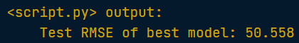

## Preprocessing for Machine Learning

### Introduction to preprocessing

#### Cleaning

* Removing rows, which don’t satisfy threshold condition:

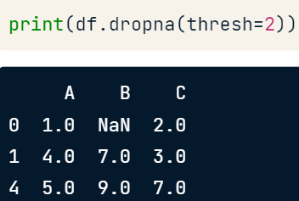

* Removing unnecessary data:

volunteer_cols = volunteer.drop(['Latitude', 'Longitude'], axis=1)

volunteer_subset = volunteer_cols.dropna(subset=['category_desc'])

print(volunteer_subset.shape)

result:

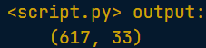

#### Working with data types

#### Training and test sets

* Stratified sampling:

X = volunteer.drop('category_desc', axis=1)

y = volunteer[['category_desc']]

X_train, X_test, y_train, y_test  = train_test_split(

            X, y,

            random_state=42,

            stratify=y

)

print(y_train['category_desc'].value_counts())

result:

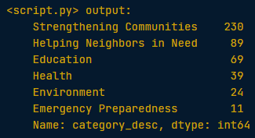

### Standardizing Data

#### Why should use

* When to standardize **linear distances**:

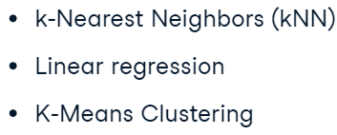

* When to standardize: **high variance**
* When to standardize: **different scales**

#### Log normalization

* Code:

print(wine['Proline'].var())

wine['Proline_log'] = np.log(wine['Proline'])

print(wine['Proline_log'].var())

code:

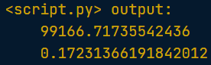

#### Scaling data for feature comparison

* What is it:

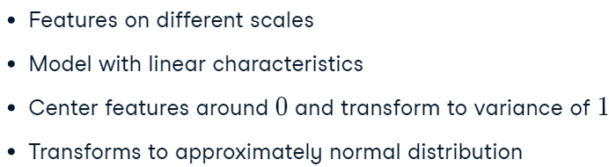

* Code:

from sklearn.preprocessing import StandardScaler

scaler = StandardScaler()

wine_subset = wine[['Ash', 'Alcalinity of ash', 'Magnesium']]

wine_subset_scaled = pd.DataFrame(scaler.fit_transform(wine_subset),

                    columns=wine_subset.columns)

result:

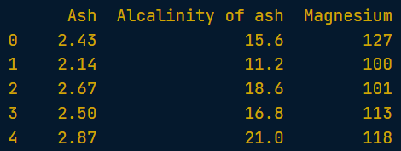

#### Standardized data and modeling

* Code:

X_train, X_test, y_train, y_test = train_test_split(X, y,

                                                    stratify=y,

                                                    random_state=42)

scaler = StandardScaler()

X_train_scaled = scaler.fit_transform(X_train)

X_test_scaled = scaler.transform(X_test)

knn.fit(X_train_scaled, y_train)

print(knn.score(X_test_scaled, y_test))

result:

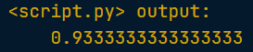

### Feature Engineering

#### Feature Engineering

* What is it:

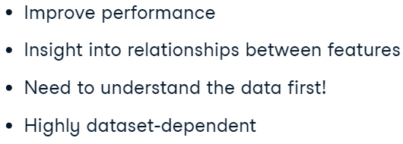

#### Encoding categorical variables

* With 1 variable:

from sklearn.preprocessing import LabelEncoder

enc = LabelEncoder()

hiking['Accessible_enc'] = enc.fit_transform(hiking['Accessible'])

print(hiking[['Accessible_enc', 'Accessible']])

result:

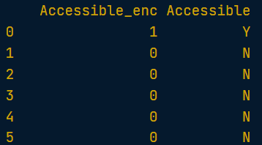

* For multiple variables:

category_enc = pd.get_dummies(volunteer['category_desc'])

print(category_enc.head())

result:

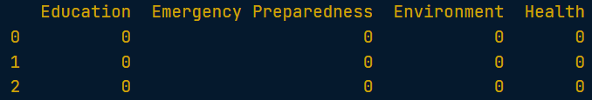

#### Engineering numerical features

* Turning several columns into one:

running_times_5k['mean'] = running_times_5k.loc[:, 'run1':'run5'].mean(axis=1)

print(running_times_5k.head())

result:

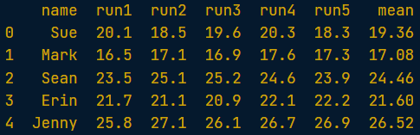

* Extracting timestamps:

volunteer['start_date_converted'] = pd.to_datetime(volunteer['start_date_date'])

volunteer['start_date_month'] = volunteer['start_date_converted'].dt.month

print(volunteer[['start_date_converted', 'start_date_month']].head())

result:

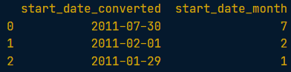

#### Engineering text features

* Vectorizing text:

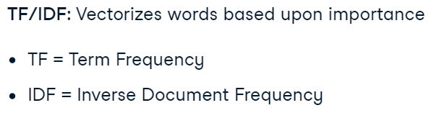

* + What uses:

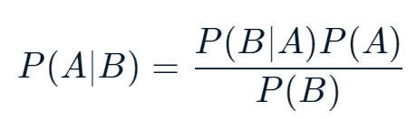

* + Code:

from sklearn.feature_extraction.text import TfidfVectorizer

title_text = volunteer["title"]

tfidf_vec = TfidfVectorizer()

text_tfidf = tfidf_vec.fit_transform(title_text)

y = volunteer["category_desc"]

X_train, X_test, y_train, y_test = train_test_split(text_tfidf.toarray(), y,

                                        stratify=y,

                                        random_state=42)

nb.fit(X_train, y_train)

print(nb.score(X_test, y_test))

result:

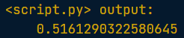

* Using regular expressions:

def return_mileage(length):

    mile = re.search('\d+\.\d+', length)

    if mile is not None:

        return float(mile.group(0))

hiking['Length_num'] = hiking['Length'].apply(return_mileage)

print(hiking[["Length", "Length_num"]].head())

result:

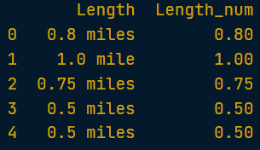

### Selecting Features for Modeling

* Why we need that:

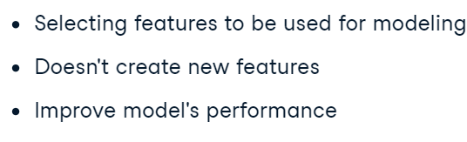

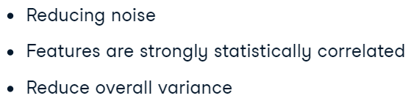

#### Removing redundant features

* What to do:

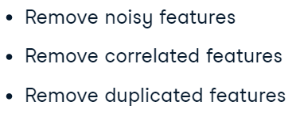

* Correlated features:

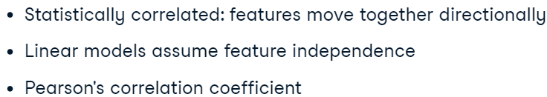

* Remove noisy features

to_drop = ['locality', 'region', 'category_desc', 'created_date', 'vol_requests']

volunteer_subset = volunteer.drop(to_drop, axis=1)

print(volunteer_subset.head())

* Correlated features:

print(wine.corr())

wine = wine.drop(['Flavanoids'], axis=1)

result:

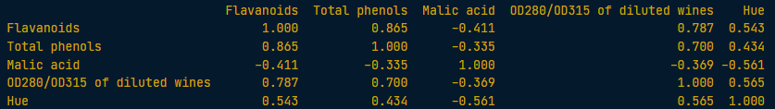

#### Selecting features using text vectors

* Looking at word weights:

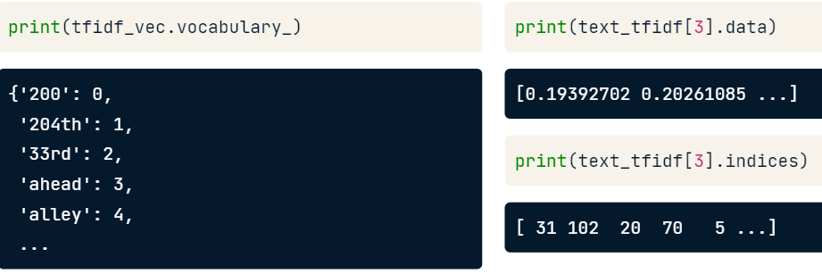

* Looking at word weights:

def return_weights(vocab, original_vocab, vector, vector_index, top_n):

    zipped = dict(zip(vector[vector_index].indices,

                        vector[vector_index].data))

    zipped_series = pd.Series({vocab[i]:zipped[i]

                                for i in vector[vector_index].indices})

    # Sort the series to pull out the top n weighted words

    zipped_index = zipped_series.sort_values(ascending=False)[:top_n].index

    return zipped_index

print(return_weights(vocab, tfidf_vec.vocabulary_, text_tfidf, 8, top_n=3))

result:



* Finding top words in the document:

def words_to_filter(vocab, original_vocab, vector, top_n):

    filter_list = []

    for i in range(0, vector.shape[0]):

        filtered = return_weights(vocab, original_vocab, vector, i, top_n)

        filter_list.extend(filtered)

    return set(filter_list)

filtered_words = words_to_filter(vocab, tfidf_vec.vocabulary_, text_tfidf, 3)

filtered_text = text_tfidf[:, list(filtered_words)]

result:

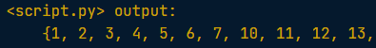

* Train model:

X_train, X_test, y_train, y_test = train_test_split(filtered_text.toarray(), y,

                                                    stratify=y,

                                                    random_state=42)

nb.fit(X_train, y_train)

print(nb.score(X_test, y_test))

result:

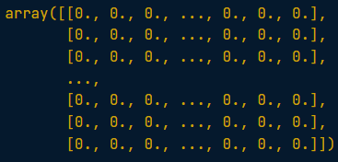

#### Dimensionality reduction – AFTER ALL YOU SHOULD APPLY IT

* What is it:

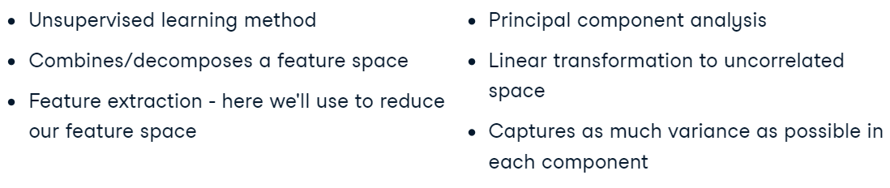

* Code:

from sklearn.decomposition import PCA

pca = PCA()

X = wine.drop('Type', axis=1)

y = wine['Type']

X_train, X_test, y_train, y_test = train_test_split(X, y,

                                                    stratify=y,

                                                    random_state=42)

pca_X_train = pca.fit_transform(X_train)

pca_X_test = pca.transform(X_test)

print(pca.explained_variance_ratio_)

knn.fit(pca_X_train, y_train)

print(knn.score(pca_X_test, y_test))

result:

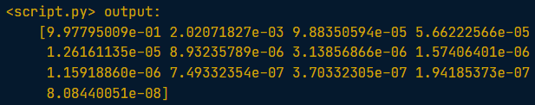

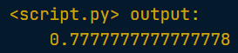

## Extreme Gradient Boosting with XGBoost

### Classification with XGBoost

#### Basics

* SL considirations:

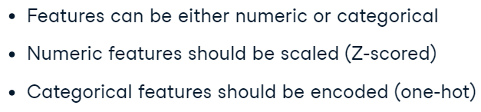

* Ranking:

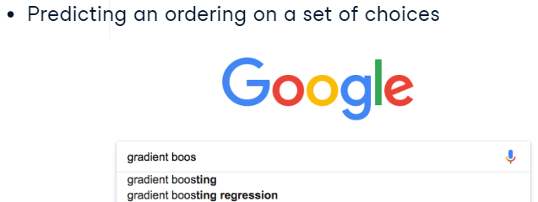

* Recommendations:

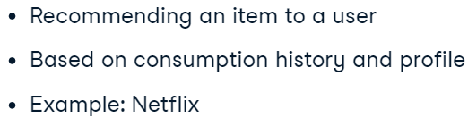

#### Introducing XGBoost

* Code:

import xgboost as xgb

xg_cl = xgb.XGBClassifier(n_estimators=10,

            objective='binary:logistic',

            seed=123

)

xg_cl.fit(X_train, y_train)

preds = xg_cl.predict(X_test)

accuracy = float(np.sum(preds==y_test))/y_test.shape[0]

print("accuracy: %f" % (accuracy))

print:

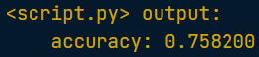

* DT as base learners:

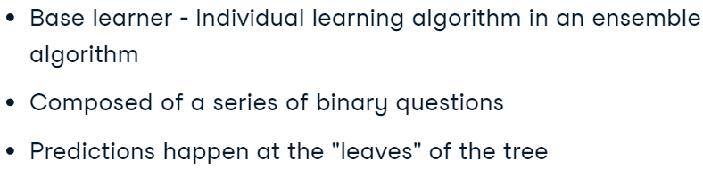

#### What is Boosting?

* What is it:

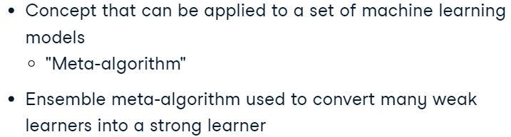

* Weak learners and strong learners

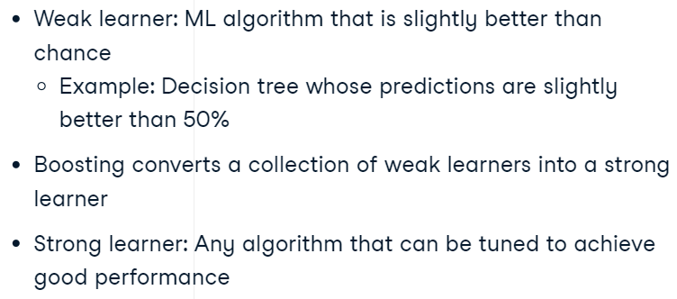

* The process:

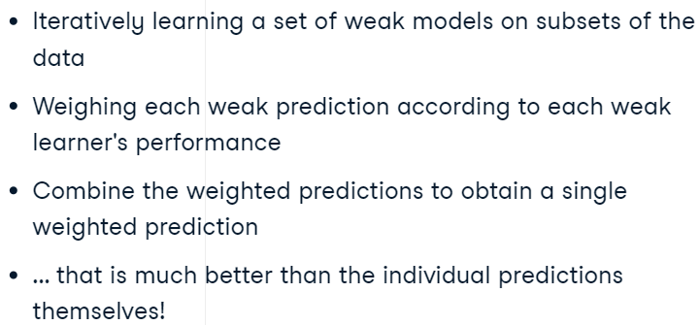

* Cross-validation for errors:

X, y = churn_data.iloc[:,:-1], churn_data.iloc[:,-1]

churn_dmatrix = xgb.DMatrix(data=X, label=y)

params = {"objective":"reg:logistic", "max_depth":3}

cv_results = xgb.cv(dtrain=churn_dmatrix,

                    params=params,

                    nfold=3,

                    num_boost_round=5,

                    metrics='error',

                    as_pandas=True,

                    seed=123

)

print(cv_results)

print((1-cv_results['test-error-mean']).iloc[-1])

* + Nfold – number of cv-folds;
  + num_boost_round – number of trees we want ot build.

result:



* CV for AUC:

cv_results = xgb.cv(dtrain=churn_dmatrix,

                params=params,

                nfold=3, num_boost_round=5,

                metrics="auc", as_pandas=True, seed=123)

print(cv_results)

print((cv_results["test-auc-mean"]).iloc[-1])

result:



#### When to use

* Should:

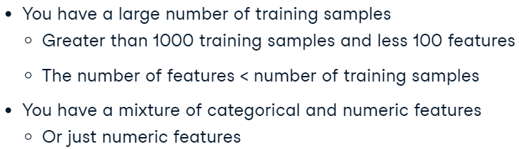

* Should not:

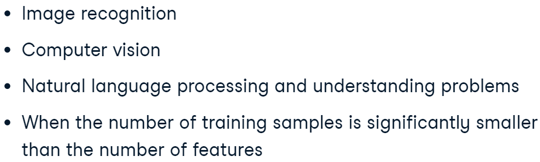

### Regression with XGBoost

#### Objective (loss) functions and base learners

* Common loss functions:

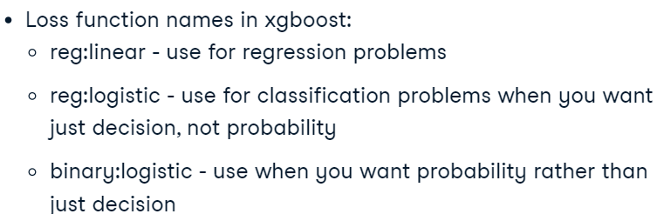

* Base learners:

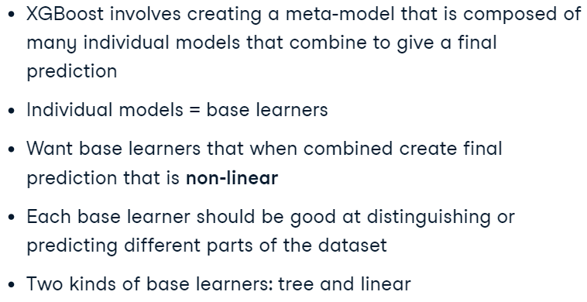

* **Decision trees** base learners:

X_train, X_test, y_train, y_test = train_test_split(X, y,

                                        test_size=0.2,

                                        random_state=123)

xg_reg = xgb.XGBRegressor(objective='reg:linear',

                          seed=123,

                          booster='gbtree',

                          n_estimators=10

)

xg_reg.fit(X_train, y_train)

preds = xg_reg.predict(X_test)

result:



* **Linear** **base** learners:

DM_train = xgb.DMatrix(data=X_train, label=y_train)

DM_test = xgb.DMatrix(data=X_test, label=y_test)

params = {'booster':'gblinear', 'objective':'reg:linear'}

xg_reg = xgb.train(dtrain=DM_train,

                    params=params,

                    num_boost_round=5

)

preds = xg_reg.predict(DM_test)

result:

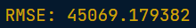

* Assessing model perfomance:

housing_dmatrix = xgb.DMatrix(data=X, label=y)

params = {"objective":"reg:linear", "max_depth":4}

cv_results = xgb.cv(dtrain=housing_dmatrix, params=params,

                    metrics='mae', num_boost_round=5,

                    nfold=4, seed=123, as_pandas=True

)

print(cv_results)

print((cv_results["test-mae-mean"]).tail(1))

result:



#### Regularization and base learners in XGBoost

* Regularization in XGBoost:

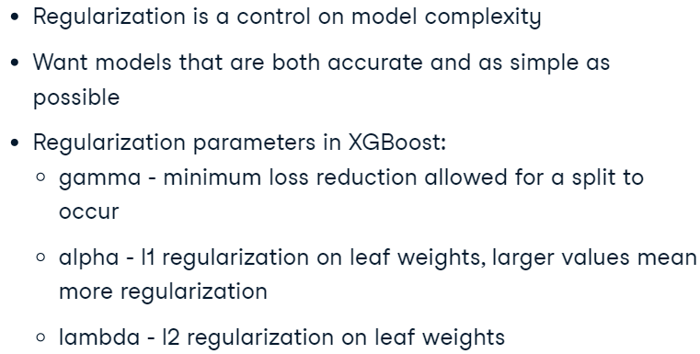

* Base learners:

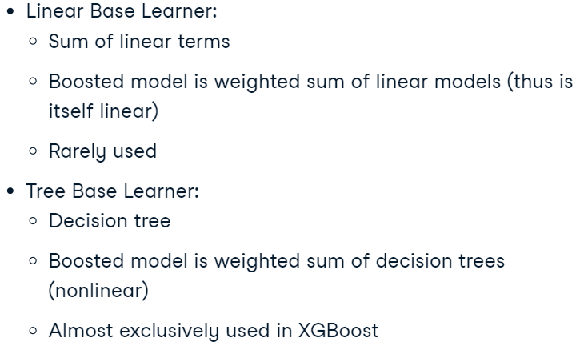

* Code for **L2**:

housing_dmatrix = xgb.DMatrix(data=X, label=y)

reg_params = [0.01, 0.1, 0.5, 1, 10, 100]

params = {'objective':'reg:linear', 'max_depth':3}

rmses_l2 = []

for reg in reg_params:

    params['lambda'] = reg

    cv_results = xgb.cv(dtrain=housing_dmatrix, params=params,

                        nfold=2, num_boost_round=5, metrics="rmse",

                        as_pandas=True, seed=123)

    rmses_l2.append(cv_results['test-rmse-mean'].tail(1).values[0])

print("Best rmse as a function of l2:")

print(pd.DataFrame(list(zip(reg_params, rmses_l2)), columns=["l2", "rmse"]))

result:

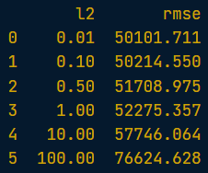

* Building trees – provides you with understanding, how the tree makes decisions:

housing_dmatrix = xgb.DMatrix(data=X, label=y)

params = {"objective":"reg:linear", "max_depth":2}

xg_reg = xgb.train(params=params, dtrain=housing_dmatrix, num_boost_round=10)

xgb.plot_tree(xg_reg, num_trees=9, rankdir="LR")

plt.show()

* + Lankdir – rotates the way it visulized;
  + Num_trees – какое дерево изображаем из ансамбля деревьев, которые заданы в модели (num_boost_round).

result:

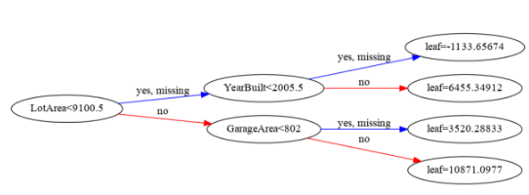

* Visualizing feature importances:

housing_dmatrix = xgb.DMatrix(X, y)

params = {'objective':'reg:linear', 'max_depth':4}

xg_reg = xgb.train(params=params, dtrain=housing_dmatrix, num_boost_round=10)

xgb.plot_importance(xg_reg)

plt.show()

result:

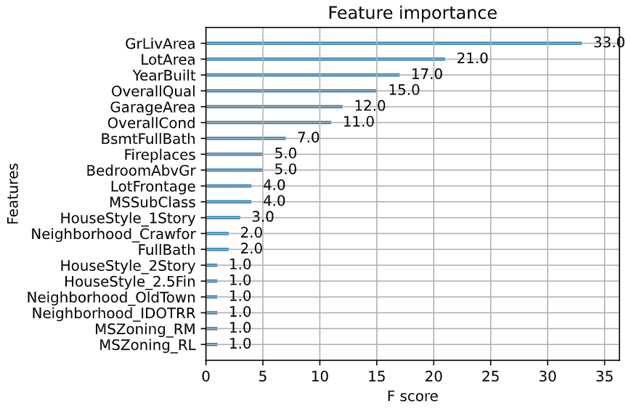

### Fine-tuning XGBoost model

#### Tuning

* Code:

housing_dmatrix = xgb.DMatrix(X, y)

params = {'objective':'reg:linear', 'max_depth':3}

num_rounds = [5, 10, 15]

final_rmse_per_round = []

for i in num_rounds:

    cv_results = xgb.cv(dtrain=housing_dmatrix, params=params,

                 metrics='rmse', num_boost_round=i, nfold=3,

                 as_pandas=True, seed=123)

    final_rmse_per_round.append(cv_results['test-rmse-mean'].tail().values[-1])

num_rounds_rmses = list(zip(num_rounds, final_rmse_per_round))

print(pd.DataFrame(num_rounds_rmses, columns=["num_boosting_rounds","rmse"]))

result:

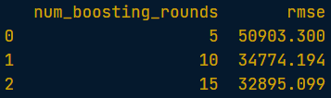

* **Early stopping:**

Якщо значення метрики якості на цьому тестовому наборі не покращується протягом певної кількості раундів (визначеної параметром **early_stopping_rounds**) – то навчання припиняється.

Якщо метрика на тестовому наборі продовжує покращуватися аж до завершення всіх раундів навчання (вказаних у num_boost_rounds), то рання зупинка не відбувається.

Це означає, що якщо модель надалі покращується на тестовому наборі або залишається стабільною, то немає необхідності зупиняти навчання раніше вказаної кількості раундів.

housing_dmatrix = xgb.DMatrix(data=X, label=y)

params = {"objective":"reg:linear", "max_depth":4}

cv_results = xgb.cv(dtrain=housing_dmatrix, params=params,

                    metrics='rmse', nfold=3, early_stopping_rounds=10,

                    num_boost_round=50, seed=123, as_pandas=True)

print(cv_results)

#### Overview of XGBoost's hyperparameters

* For **tree**:

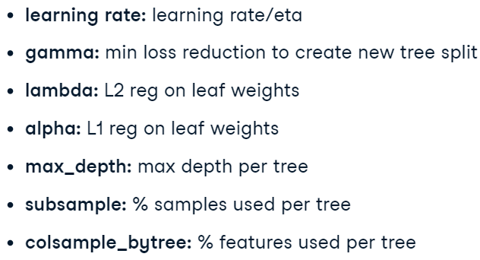

* + Learning rate: is a parameter that can range between 0 and 1, with higher values of "eta" penalizing feature weights more strongly, causing much stronger regularization;
  + Subsample: low values lead to undefitting, when big to overfitting;
  + Colsample_bytree: : low values lead to regularization, when big to overfitting;
* For **linear**:

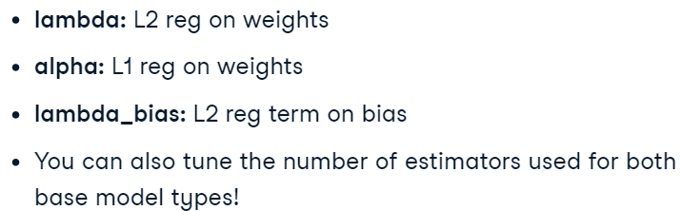

* Code for **learning rate**:

housing_dmatrix = xgb.DMatrix(data=X, label=y)

params = {"objective":"reg:linear", "max_depth":3}

eta_vals = [0.001, 0.01, 0.1]

best_rmse = []

for curr_val in eta_vals:

    params["eta"] = curr_val

    cv_results = xgb.cv(dtrain=housing_dmatrix, params=params,

                        metrics='rmse', num_boost_round=10,

                        early_stopping_rounds=5, nfold=3,

                        seed=123, as_pandas=True)

    print(cv_results)

    best_rmse.append(cv_results["test-rmse-mean"].tail().values[-1])

print(pd.DataFrame(list(zip(eta_vals, best_rmse)), columns=["eta","best_rmse"]))

result:

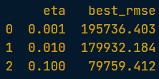

* Tuning **max_depth**:

params = {"objective":"reg:linear"}

max_depths = [2, 5, 10, 20]

best_rmse = []

for curr_val in max_depths:

    params["max_depth"] = curr_val

    cv_results = xgb.cv(dtrain=housing_dmatrix, params=params,

                        metrics='rmse', num_boost_round=10,

                        early_stopping_rounds=5, nfold=2,

                        seed=123, as_pandas=True)

    best_rmse.append(cv_results["test-rmse-mean"].tail().values[-1])

print(pd.DataFrame(list(zip(max_depths, best_rmse)),columns=["max_depth","best_rmse"]))

result:

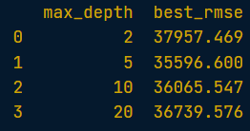

* Tuning **colsample_bytree**:

housing_dmatrix = xgb.DMatrix(data=X,label=y)

params={"objective":"reg:linear","max_depth":3}

colsample_bytree_vals=[0.1, 0.5, 0.8, 1]

best_rmse = []

for curr_val in colsample_bytree_vals:

    params['colsample_bytree'] = curr_val

    cv_results = xgb.cv(dtrain=housing_dmatrix, params=params, nfold=2,

                 num_boost_round=10, early_stopping_rounds=5,

                 metrics="rmse", as_pandas=True, seed=123)

    best_rmse.append(cv_results["test-rmse-mean"].tail().values[-1])

print(pd.DataFrame(list(zip(colsample_bytree_vals, best_rmse)), columns=["colsample_bytree","best_rmse"]))

#### Grid search and random search

* Grid search:

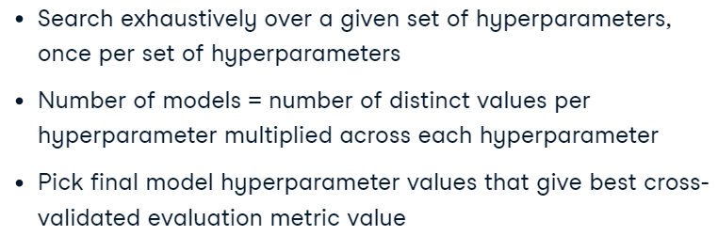

* Random search:

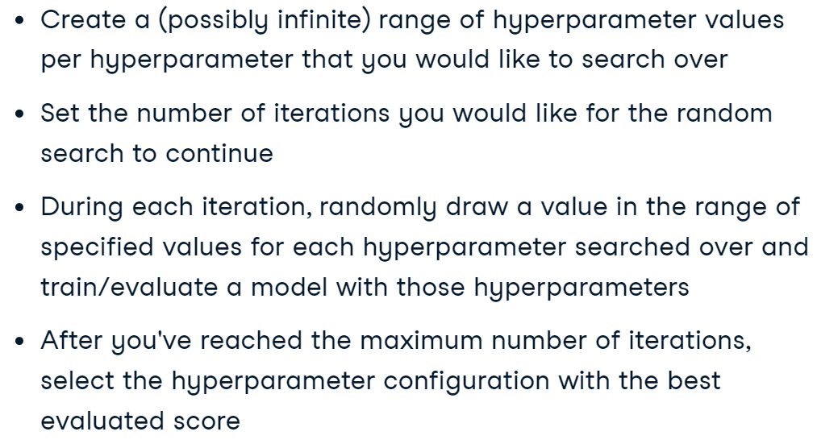

* Code for **GS**:

gbm_param_grid = {'colsample_bytree':[0.3, 0.7],

                  'n_estimators':[50],

                  'max_depth':[2, 5]}

gbm = xgb.XGBRegressor()

grid_mse = GridSearchCV(estimator=gbm,

                        param_grid=gbm_param_grid,

                        cv=4, scoring='neg_mean_squared_error',

                        verbose=1)

grid_mse.fit(X, y)

print("Best parameters found: ", grid_mse.best_params_)

print("Lowest RMSE found: ", np.sqrt(np.abs(grid_mse.best_score_)))

result:

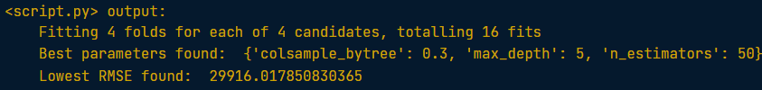

* Code for **RS**:

gbm_param_grid = {'n_estimators':[25],

                  'max_depth':range(2, 12)}

gbm = xgb.XGBRegressor(n_estimators=10)

randomized_mse = RandomizedSearchCV(estimator=gbm,

                                    scoring='neg_mean_squared_error',

                                    param_distributions=gbm_param_grid,

                                    n_iter=5, cv=4, verbose=1)

randomized_mse.fit(X, y)

print("Best parameters found: ", randomized_mse.best_params_)

print("Lowest RMSE found: ", np.sqrt(np.abs(randomized_mse.best_score_)))

* + Verbose – first line of output;
  + N_iter – how many times it will iterate.

result:

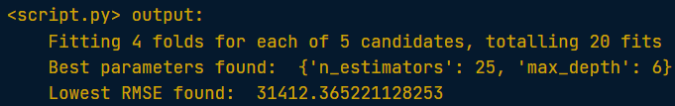

#### Limits of grid search and random search

* Limitations:

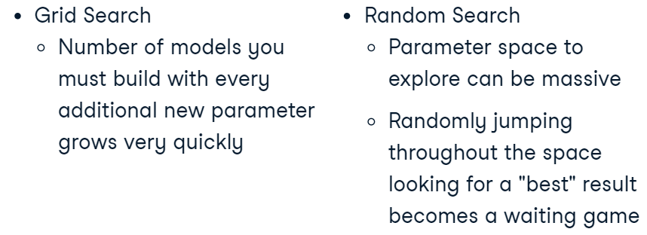

### Using XGBoost in pipelines

#### LabelEncoder and OneHotEncoder

* What is it:

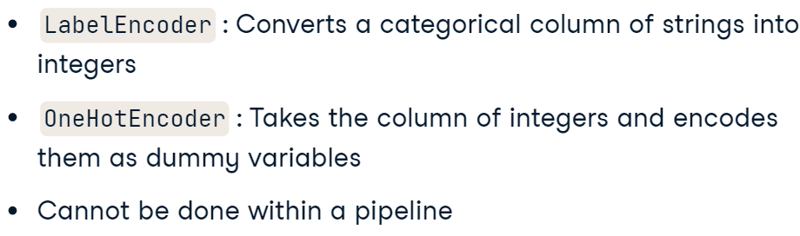

* Code for **LE**:

from sklearn.preprocessing import LabelEncoder

df.LotFrontage = df.LotFrontage.fillna(0)

categorical_mask = (df.dtypes==object)

categorical_columns = df.columns[categorical_mask].tolist()

print(df[categorical_columns].head())

le = LabelEncoder()

df[categorical_columns] = df[categorical_columns].apply(lambda x: le.fit_transform(x))

print(df[categorical_columns].head())

result:

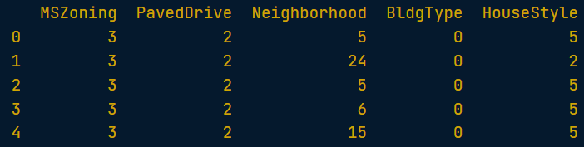

* Code for **OHE**:

from sklearn.preprocessing import OneHotEncoder

ohe = OneHotEncoder(sparse=False, handle_unknown='ignore')

df_encoded = ohe.fit_transform(df)

print(df_encoded[:5, :])

print(df_encoded.shape)

print(df.shape)

result:

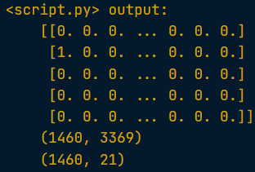

#### DictVectorizer

* What is it:

**DictVectorizer** принимает *словари* в качестве входных данных и преобразует их в матрицу. Каждый словарь представляет собой одну строку данных, где ключи словаря являются названиями признаков, а значения - значениями признаков.

* Code:

from sklearn.feature_extraction import DictVectorizer

df_dict = df.to_dict('records')

dv = DictVectorizer(sparse=False)

df_encoded = dv.fit_transform(df_dict)

print(df_encoded[:5, :])

print(dv.vocabulary_)

* + Dv.vocabulary_ – индексирует каждую колонку уникальныйм числом.

#### Pipeline

* Code:

from sklearn.pipeline import Pipeline

from sklearn.feature_extraction import DictVectorizer

X.LotFrontage = X.LotFrontage.fillna(0)

steps = [

    ('ohe_onestep', DictVectorizer(sparse=False)),

    ('xgb_model', xgb.XGBRegressor())

]

xgb_pipeline = Pipeline(steps)

xgb_pipeline.fit(X.to_dict('records'), y)

#### Incorporating XGBoost into pipelines

* Preprocessing:

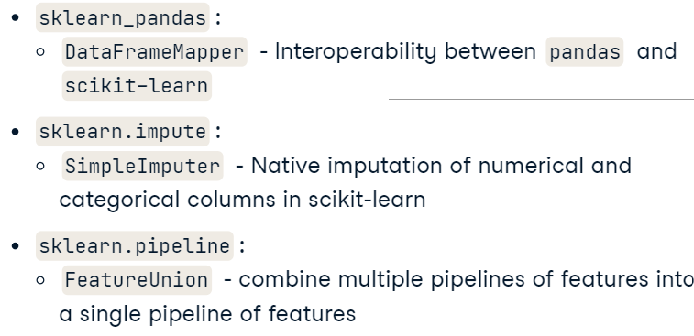

* Code for the step #1:

from sklearn_pandas import DataFrameMapper

from sklearn.impute import SimpleImputer

from sklearn.pipeline import FeatureUnion

categorical_feature_mask = X.dtypes == 'object'

categorical_columns = X.columns[categorical_feature_mask].to_list()

non_categorical_columns = X.columns[~categorical_feature_mask].to_list()

numeric_imputation_mapper = DataFrameMapper(

    [([numeric_feature], SimpleImputer(strategy='median')) for numeric_feature in non_categorical_columns]

    input_df=True,

    df_out=True

)

categorical_imputation_mapper = DataFrameMapper(

    [(i, SimpleImputer(strategy="most_frequent")) for i in categorical_columns],

    input_df=True,

    df_out=True

)

numeric_categorical_union = FeatureUnion([

                                          ("num_mapper", numeric_imputation_mapper),

                                          ("cat_mapper", categorical_imputation_mapper)

                                         ])

pipeline = Pipeline([

    ("featureunion", numeric_categorical_union),

    ("dictifier", Dictifier()),

    ("vectorizer", DictVectorizer(sort=False)),

    ("clf", xgb.XGBClassifier(max_depth=3)),

])

cross_val_scores = cross_val_score(pipeline, kidney_data, y,

                        scoring="roc_auc", cv=3)

print("3-fold AUC: ", np.mean(cross_val_scores))

* Distifier – это класс из библиотеки sklearn-pandas, который преобразует DataFrame (таблицу данных) **в список словарей** Python.

result:

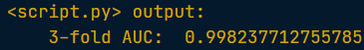

* Tuning params:

gbm_param_grid = {

    'clf__learning_rate':np.arange(0.05, 1, 0.05),

    'clf__max_depth':np.arange(3, 10),

    'clf__n_estimators':np.arange(50, 200, 50)

}

randomized_roc_auc = RandomizedSearchCV(estimator=pipeline,

                                        param_distributions=gbm_param_grid,

                                        n_iter=2, cv=2,

                                        scoring='roc_auc',

                                        verbose=1

)

randomized_roc_auc.fit(X, y)

## Hyperparameter Tuning in Python

### Informed Search: Coarse to Fine

* What is it:

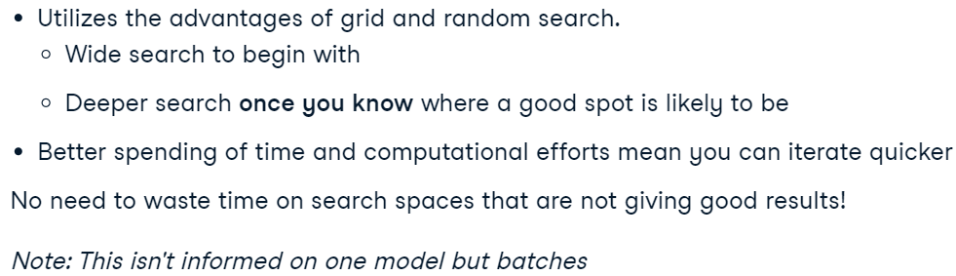

* Informed vs uninformed search:

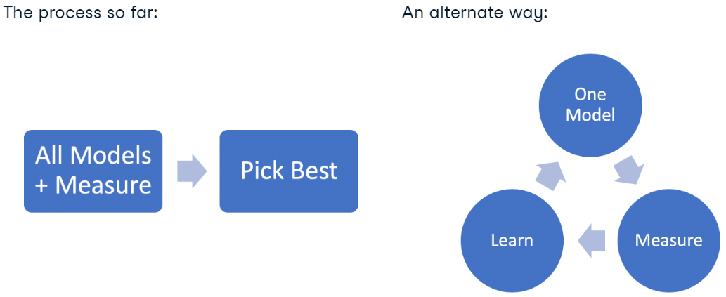

* The process:

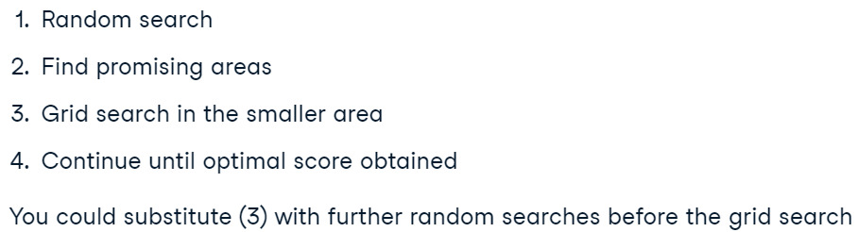

* Analisys after watching on pictures:

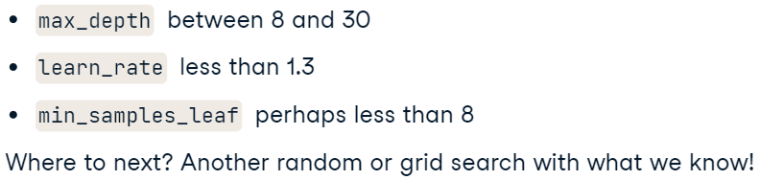

* Code for analizing each param separatly:

def visualize_hyperparameter(name):

plt.clf()

plt.scatter(results_df[name],results_df['accuracy'], c=['blue']*500)

plt.gca().set(xlabel='{}'.format(name), ylabel='accuracy', title='Accuracy for different {}s'.format(name))

plt.gca().set_ylim([0,100])

plt.show()

print(results_df.sort_values('accuracy', ascending=False).head(10))

visualize_hyperparameter('max_depth')

visualize_hyperparameter('min_samples_leaf')

visualize_hyperparameter('learn_rate')

result:

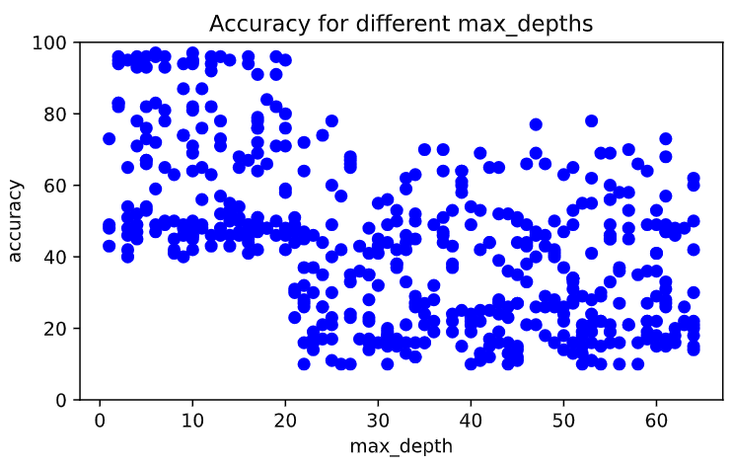

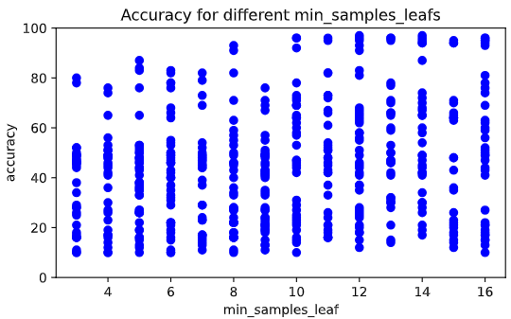

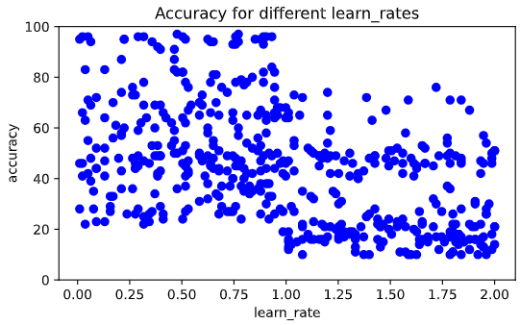

### Informed Search: Bayesian Statistics

* Rule:

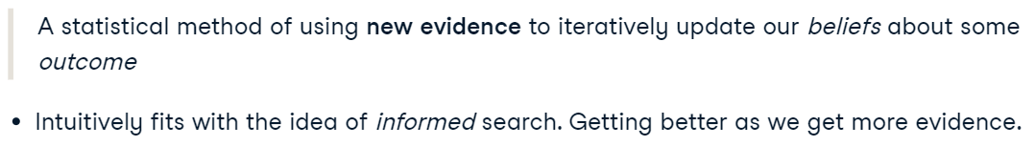

* How it works:

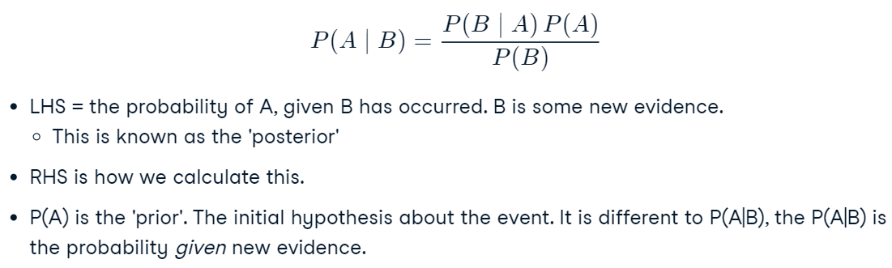

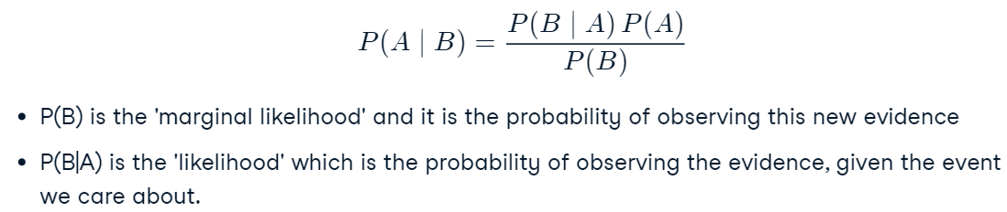

* How it works:

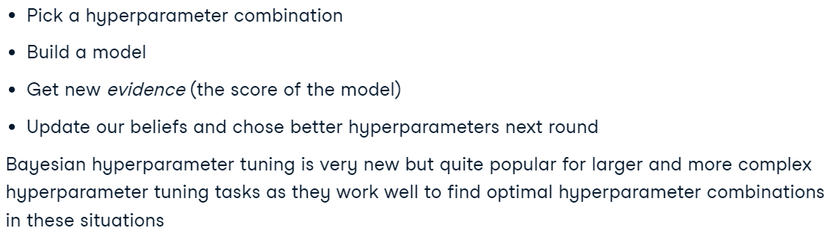

* Finding probs:

You interview one of your customers and discover they are unhappy. What is the probability they will close their account:

p_unhappy = 0.15

p_unhappy_close = 0.35

p_close = 0.07

p_close_unhappy = (p_unhappy_close * p_close) / p_unhappy

print(p_close_unhappy)

result:

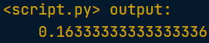

* Code:

import Hyperplot as hp

space = {

    'max_depth':hp.quniform('max_depth', 2, 10, 2),

    'learning_rate':hp.uniform('learning_rate', 0.001, 0.9)

}

def objective(params):

    params = {

        'max_depth':int(params['max_depth']),

        'learning_rate':params['learning_rate']

    }

    gbm_clf=GradientBoostingClassifier(n_estimators=100, **params)

    best_score = cross_val_score(gbm_clf, X_train, y_train,

                                scoring='accuracy', cv=2,

                                n_jobs=-1).mean()

    loss = 1 - best_score

    return loss

best = fmin(fn=objective,

            space=space,

            max_evals=20,

            rstate=np.random.default_rng(42),

            algo=tpe.suggest)

print(best)

* Max_evals – Это количество итераций (попыток), которые алгоритм оптимизации будет выполнять для поиска наилучших гиперпараметров;
* Algo – это алгоритм, который будет использоваться для оптимизации.

result:



### Informed Search: Genetic Algorithms

* How it works:

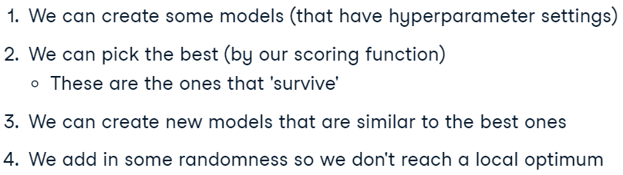

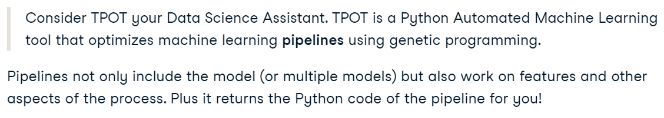

* TPOT components:

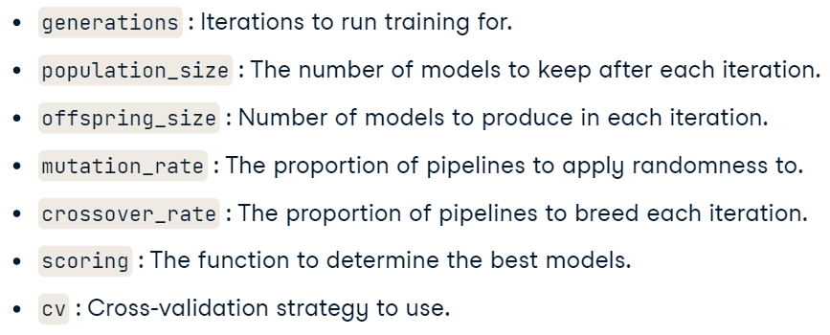

* Code:

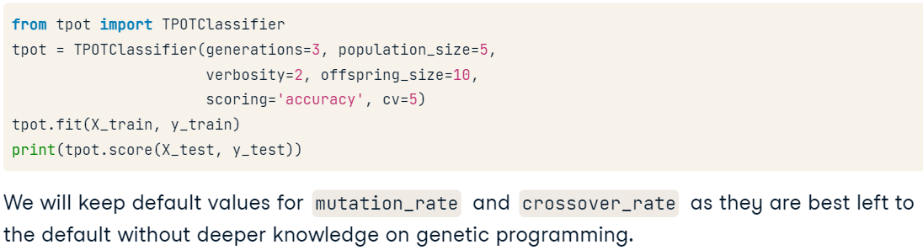

from tpot import TPOTClassifier

number_generations = 3

population_size = 4

offspring_size = 3

scoring_function = 'accuracy'

tpot_clf = TPOTClassifier(generations=number_generations,

                        population_size=population_size,

                        offspring_size=offspring_size,

                        scoring=scoring_function,

                        verbosity=2, random_state=2, cv=2)

tpot_clf.fit(X_train, y_train)

print(tpot_clf.score(X_test, y_test))

result:



* Explonation:

You can see that **TPOT** is quite unstable when only running with low generations, population size and offspring, when using different random_state. The first model chosen was a Decision Tree, then a K-nearest Neighbor model and finally a Random Forest. Increasing the generations, population size and offspring and running this for a long time will assist to produce better models and more stable results.

## Winning a Kaggle Competition in Python

### Dive into the Competition

#### Overfitting

* Code for searching **overfitting** point:

from sklearn.metrics import mean_squared_error

dtrain = xgb.DMatrix(data=train[['store', 'item']])

dtest = xgb.DMatrix(data=test[['store', 'item']])

for model in [xg_depth_2, xg_depth_8, xg_depth_15]:

    train_pred = model.predict(dtrain)

    test_pred = model.predict(dtest)

    mse_train = mean_squared_error(train['sales'], train_pred)

    mse_test = mean_squared_error(test['sales'], test_pred)

    print('MSE Train: {:.3f}. MSE Test: {:.3f}'.format(mse_train, mse_test))

result:

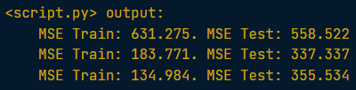

* Solution workflow:

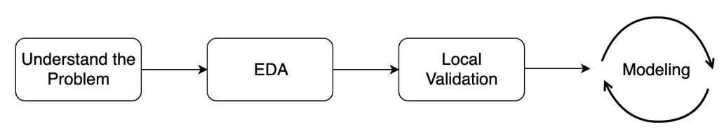

#### Initial EDA

* Explore you data (describe, data_type) and explore your target variable;
* Plot your findings;

#### Local validation

* Code for StritifiedKFold:

from sklearn.model_selection import StratifiedKFold

str_kf = StratifiedKFold(n_splits=3, shuffle=True, random_state=123)

fold = 0

for train_index, test_index in str_kf.split(train, train['interest_level']):

    cv_train, cv_test = train.iloc[train_index], train.iloc[test_index]

    print('Fold: {}'.format(fold))

    print('CV train shape: {}'.format(cv_train.shape))

    print('Medium interest listings in CV train: {}\n'.format(sum(cv_train.interest_level == 'medium')))

    fold += 1

result:

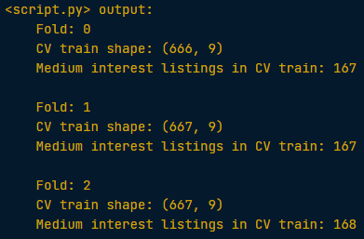

#### Validation usage

* Leakage:

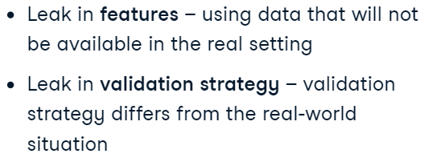

* How works **TimeSeriesSplit**:

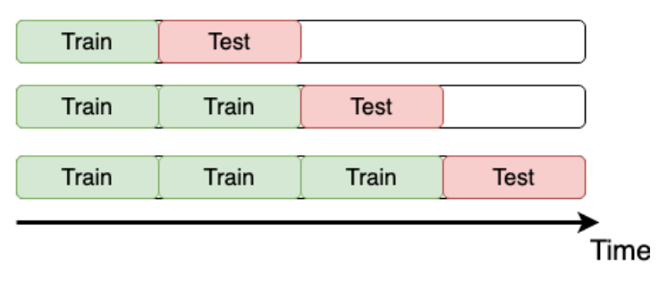

* Metrics:

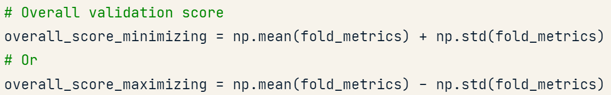

* Validating pipeline:

from sklearn.model_selection import TimeSeriesSplit

time_kfold = TimeSeriesSplit(n_splits=3)

train = train.sort_values('date')

fold = 0

for train_index, test_index in time_kfold.split(train):

    cv_train, cv_test = train.iloc[train_index], train.iloc[test_index]

    print('Fold :', fold)

    print('Train date range: from {} to {}'.format(cv_train.date.min(), cv_train.date.max()))

    print('Test date range: from {} to {}\n'.format(cv_test.date.min(), cv_test.date.max()))

    fold += 1

result:

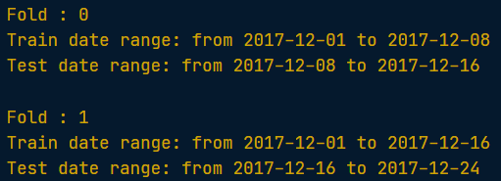

### Feature engineering

#### Feature Engineering

* Modeling stage:

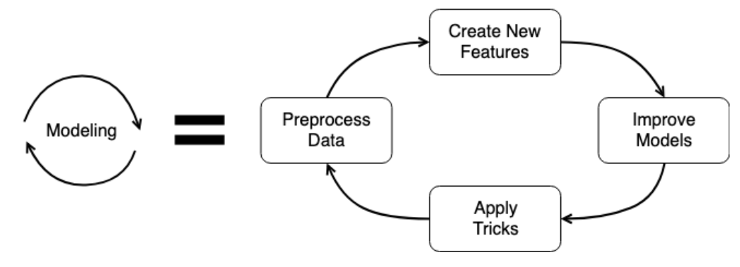

* Features types:

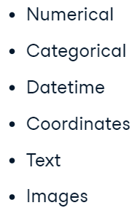

* Creating features:

print('RMSE before feature engineering:', get_kfold_rmse(train))

train['TotalArea'] = train['TotalBsmtSF'] + train['FirstFlrSF'] + train['SecondFlrSF']

print('RMSE with total area:', get_kfold_rmse(train))

train['GardenArea'] = train['LotArea'] - train['FirstFlrSF']

print('RMSE with garden area:', get_kfold_rmse(train))

train['TotalBath'] = train['FullBath'] + train['HalfBath']

print('RMSE with number of bathrooms:', get_kfold_rmse(train))

result:

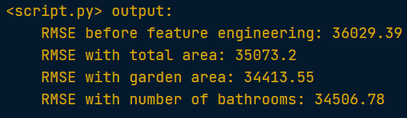

* Creating new datetime features –  perform feature engineering for train and test DataFrames simultaneously:

taxi = pd.concat([train, test])

taxi['pickup_datetime'] = pd.to_datetime(taxi['pickup_datetime'])

taxi['dayofweek'] = taxi['pickup_datetime'].dt.dow

taxi['hour'] = taxi['pickup_datetime'].dt.hour

new_train = taxi[taxi['id'].isin(train['id'])]

new_test = taxi[taxi['id'].isin(test['id'])]

#### Categorical features

* For multiple values – OneHotEncoder;
* For binary – LabelEncoder
* Code:

houses = pd.concat([train, test])

from sklearn.preprocessing import LabelEncoder

le = LabelEncoder()

houses['CentralAir_enc'] = le.fit_transform(houses['CentralAir'])

ohe = pd.get_dummies(houses['RoofStyle'], prefix='RoofStyle')

houses = pd.concat([houses, ohe])

#### Target encoding

#### Missing data

* Process:

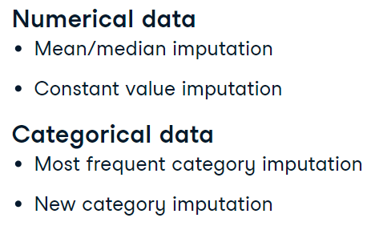

* Example:

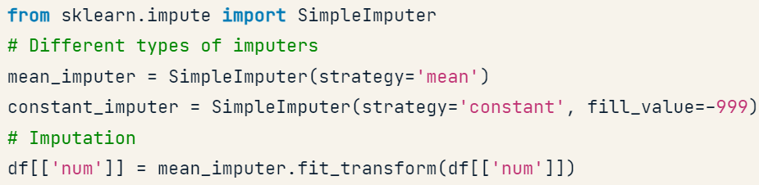

### Modeling

#### Baseline model

* Find mean values for each group.
* Influence of things on model:

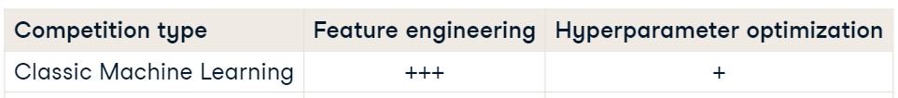

#### Model ensembling

* Model stacking:

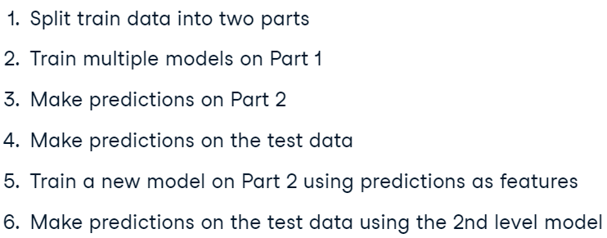

* Code:

from sklearn.model_selection import train_test_split

from sklearn.ensemble import GradientBoostingRegressor, RandomForestRegressor

part_1, part_2 = train_test_split(train, test_size=0.5, random_state=123)

gb = GradientBoostingRegressor().fit(part_1[features], part_1.fare_amount)

rf = RandomForestRegressor().fit(part_1[features], part_1.fare_amount)

part_2['gb_pred'] = gb.predict(part_2[features])

part_2['rf_pred'] = rf.predict(part_2[features])

test['gb_pred'] = gb.predict(test[features])

test['rf_pred'] = rf.predict(test[features])

lr = LinearRegression(fit_intercept=False)

lr.fit(part_2[['gb_pred', 'rf_pred']], part_2.fare_amount)

test['stacking'] = lr.predict(test[['gb_pred', 'rf_pred']])

print(lr.coef_)

result:

